William & Jones Ltd.

Welcome to the Series of W&J Small Handling Equipment

SMS4017 Battery-Power Mini Stacker

Cap. 400 kg at 300 mm crs.

Instruction Manual

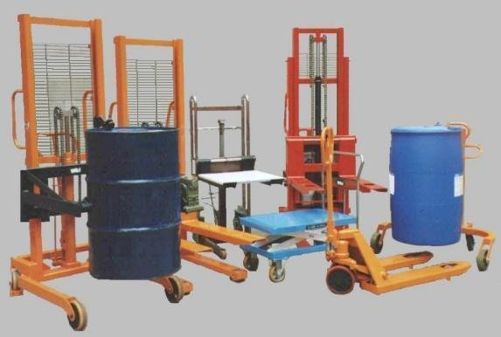

Instruction Manual

SECTION CONTENTS

- Introduction

- Loading and the Use of Equipment

- Routine Maintenance

3.1 Brake

3.2 Castors/Wheels

3.3 Hydraulic Cylinder and Oil Seal

  - Lubrication

  - Clean

  - Battery

  - Reset

- Coverage and Parts Supply

DECLARATION OF CONFORMITY
This machine complies with the essential Health and Safety Requirements relating to the Design and Construction of Machinery as defined within “The Supply of Machinery (Safety) Regulations 1992”

Signed on Behalf of :

WILLIAM & JONES LTD

Director:

Battery-Power Mini Stacker (Model No: SMS4017)

Introduction

- W&J Battery-Power Mini Stacker is ideal for Lifting, Moving, and Positioning Heavy or Awkward Items

- Lifting Pump (DC Power Pack) from Smiths for Efficient Lifting and Low Noisy Level at a Lifting Speed Approx. 10 sec./metre.

- Standard Battery (12V/135 AH).

- Battery Indicator and Battery Charger Installed.

Memo

- Cap. 400 kg

- Load Centres 300 mm

- Lift Height – Raised 1700 mm, Lowered 85 mm

- Adjustable Forks

- Fork Size (mm): 110 (W) x 650 (L)

- Overall Size (mm): 600 (W) x 1040 (L) x 1940 (H)

- Single Lifting Chain

- Twin Total Stop Wheel Brakes

- Unladen Weight Approx. 138 kg

Battery-Power Mini Stacker (Model No: SMS4017)

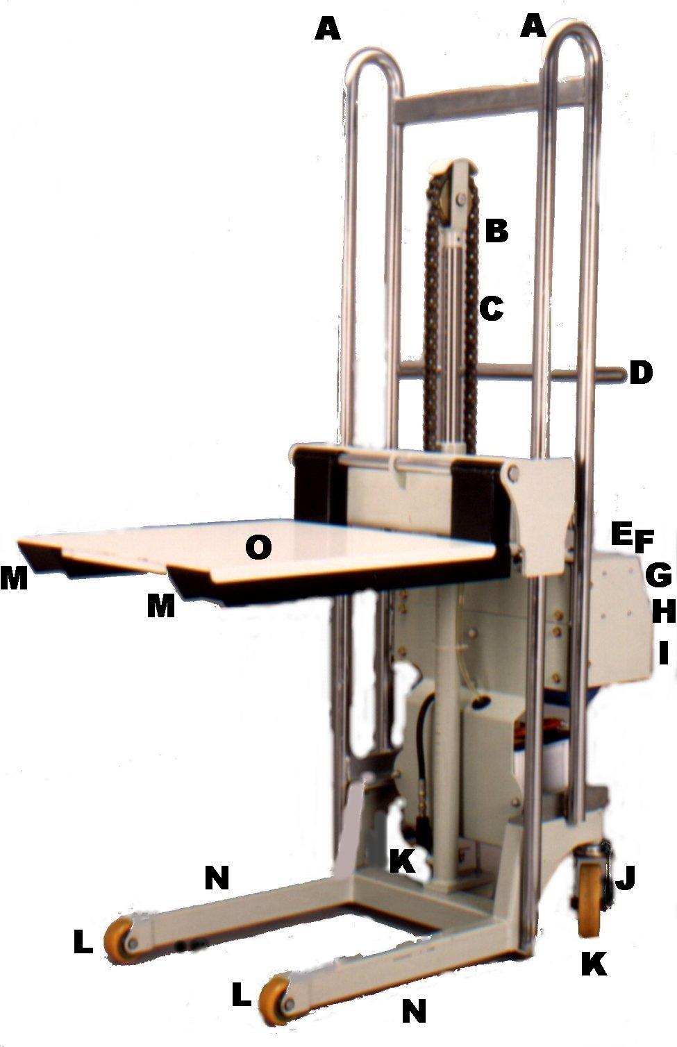
A – Mast

B – Single Lifting Chain

C – Hydraulic Cylinder

D – Push Handle

E – Up/Down Control Button

F – Battery Indicator

G – Light

H – Plug (Re-charge Cable Included)

I – Battery Charger (220 ~ 240 V) (Inside of the Electric Box)

J – Brake

K – Swivel Castors Dia. 125 mm

L – Fixed Wheels Dia. 75 mm

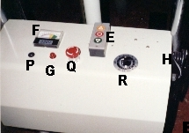
M – Adjustable Forks

N – Legs

O – Optional Platform

P – Reset (Black Button on the Control Penal)

Q – Reset/Disconnect
(Red Push Down Button on the Control Penal)

R – Battery Charger Time Controller

S – Clip

Battery-Power Mini Stacker (Model No: SMS4017)

Operation Instructions

DO NOT AND ALWAYS:

- Do Not Overload Beyond Rated Capacity
- For Safety Purpose, Do Not Re-charge Battery Overnight. (Do Not Leave Battery Charger On Overnight)
- Do Not Operate While Re-charging. Maximum Re-charging Time 8 Hours.
- Do Not Work and/or Stand Under Forks While Lifting
- Do Not Stand on the Forks While Lifting
- Always Re-charge the Battery While It Still Contains 30% Power (Battery Charger Indicator Point to 10V Position)
- Always Operate The Stacker on Level Ground
- Always Use Brake System for Safety
- Always Ensure Load is Secured Before Moving
- Always Keep Forks in The Lowest Position While Moving
- Always Re-Charge Battery While Battery Indicator Shows Low Voltage Situation
- Always Use Emergency Stop Bottom for Emergency Stop

Lifting and Lowering:

- For Safety Secure Brake System Before any Operation
- Ensure Load is Secure Before any Operation
- Push “E” up for Lifting or Lowering
- Release Brake System to Move
- For Stability Reason always Keep Forks in Lowest Position While Moving

Attachment Changing:
- Ensure the Carriage in the Low Position.
- Remove “S” (Clip) on Either Side of Bright Solid Round Bar
- Gently Remove the Solid Round Bar
- Replace the Different Attachment and Re-put the Solid Round Bar Back to The Right Position
- Re-Secure “S” (Clip) Back to the Right Position

Battery-Power Mini Stacker (Model No: SMS4017)

Routine Maintenance

Brake – Check Brake System Regularly and Make Sure Brake System Is Always in Working Condition

Castors/Wheels – Check Castors/Wheels Regularly and Make Sure they are in Good Condition.
Replace with New Castors/Wheels for an Unable Working Condition.

Hydraulic Cylinder and Oil Seals – Check If Any Oil is Leaking Regularly.
Replace Oil Seal if Necessary. Refill with Standard Hydraulic Oil such as Shell Tellus 27, If the Equipment Can Not Reach the Max. Height.

Refill Hydraulic Oil:
(1) Release/Undo 4 Screws on the Left Hand Side of the Control Panel and Then Remove the Panel (Only Where Screws Have Been Removed).
- Look Inside for a Twisting Cap and Remove It.
- Pour in the New Hydraulic Oil and Then Try to Lift The Hydraulic to Max. Height.
- Replace Panel, If The Equipment Can Be Lifted to Full Height.
***** Do Not Pour in Too Much Hydraulic Oil. This Will Cause a Failure of Lifting. *****

Lubrication – Brush a Little Amount of Grease on Chrome Tube and on the Lifting Chain Every 3 Months.

Clean – Please keep the Chrome Tube Clean at All Time. Use Cloth or Paper Tower to Clean the Chrome Tube and Entire Equipment from Time to Time.

Battery – Check if Water Level in Between Low and High Level Regularly. Suggest to Exam Every 3 Months. Refill Clean Water into Battery if Necessary. In Order to Prolong Lifetime of the Battery, Always Re-charge the Battery While It Still Contains 30% Power (Battery Charger Indicator Point to 10V Position). Replace Battery (Type 12V Standard Lead/Acid) if Necessary.

Plug Cable – Check Plug Cable Rubber Cover Regularly and Make Sure they are in Good Condition. As Exposed Wire Might Cause Fire or Explosion.

Reset (Black Button on the Control Penal) – The Function is same as Fuse. Press Reset Button while the Button Pop Up/Electric System is in Off Position.
Battery-Power Mini Stacker (Model No: SMS4017)

Diagram of Electric Control

Parts List:

1. Power Supply 2. Transformer
3. Rectifier 4. Battery (12V-70A)
5. Battery Indictor 6. Lowering Contactor
7. Lifting Contactor 8. Up & Down Switch
9. Battery Charge Time Controller (8a –> Up, 8b –> Down)
10. Fuse 11. Charger Indictor

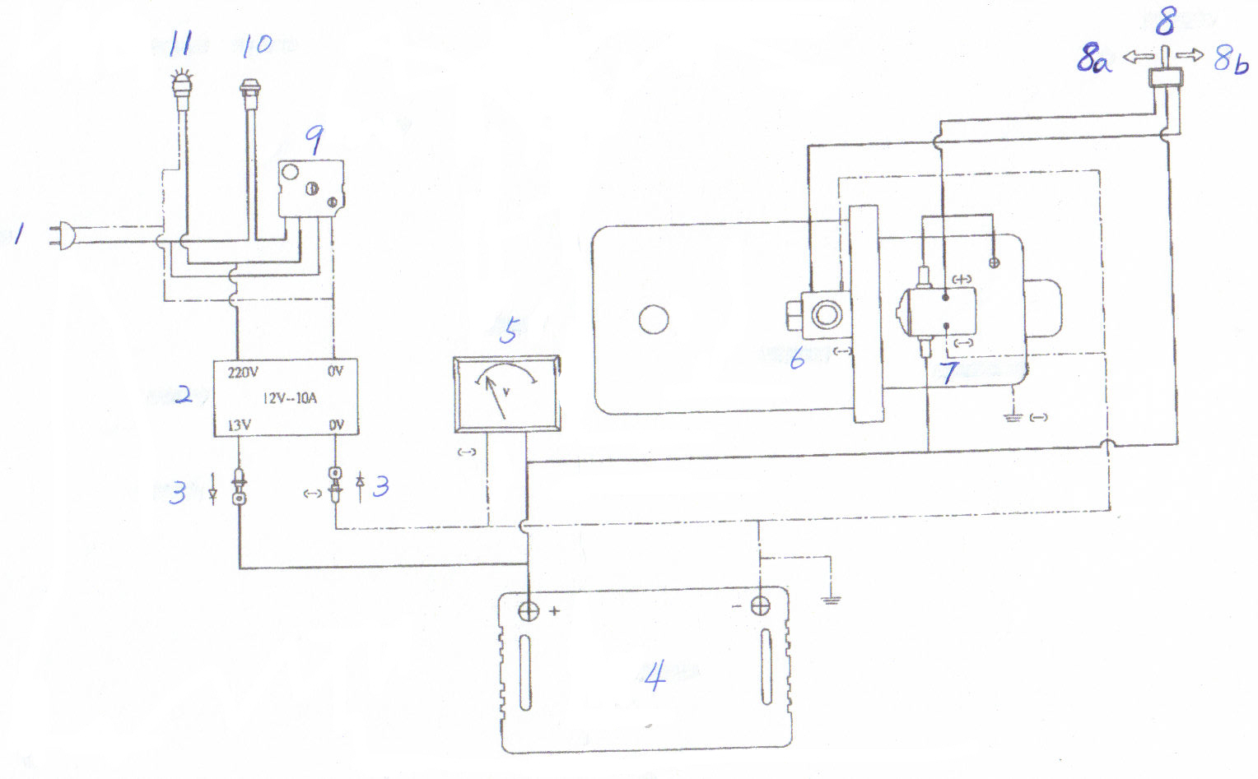
Battery-Power Mini Stacker (Model No: SMS4017)

Coverage and Parts Supply

Coverage:

- 12 Months Warranty Which Battery, Castors/Wheels and Oil Seals Are Not Included
- We Do Not Cover Any Wear and Tear that caused by Misusing or Abusing the Equipment

Parts Supply:

- W&J Equipment Are Standard Products. Spare Parts May Purchase from William & Jones Ltd. or In Certain Parts Supplier.

