Instruction Manual

Rough Terrain Truck

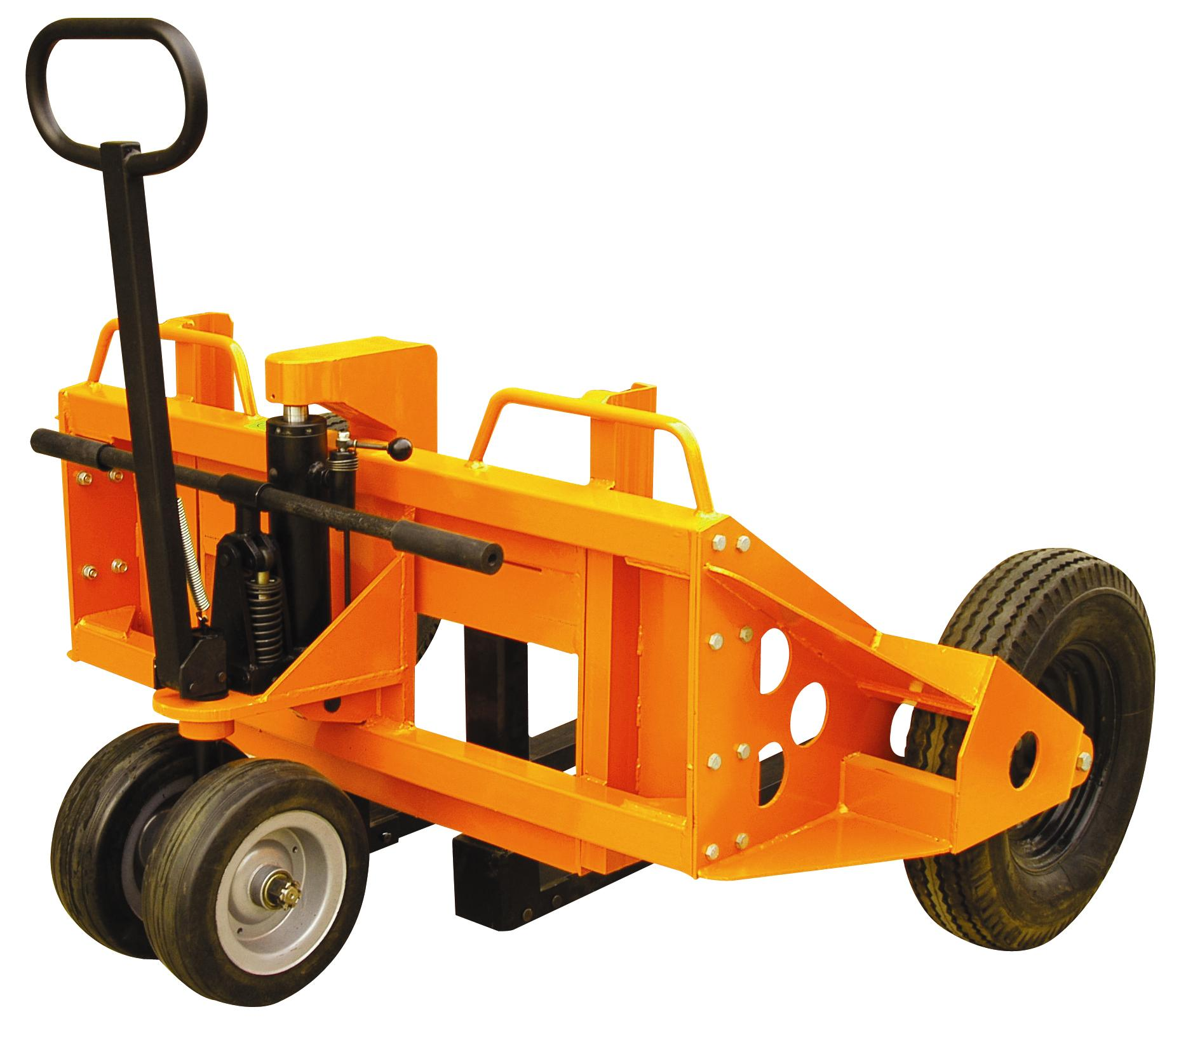

Note: Owner/Operator must read and understand this instruction manual before using the truck.

Thank you for choosing our product.
Before using this product, please read this manual carefully, understand the construction and performance, and operate, maintain according to the manual. Overload is especially forbidden to avoid injuring person, damage of load and truck. Any damage or injuring which is caused by change of truck without the permission is nothing to do with the manufacturer.

Contents

- Preface

- Specification

- Steps of Installation

- Operating Instructions

- Safety Guide

- Maintenance

- Hydraulic Circuit

- Troubles Shooting

- Exploded View & Parts List

- Preface
The Rough Terrain Truck is suitable for using at construction site, factories, buildings and roads, transports various materials.
  - Because of the two Φ568mm front wheels and twoΦ315mm steering wheels, the truck is suitable for any condition of the road. And the front wheels are pneumatic, it can reduce the friction force, minish the vibration. You can operate it easily and steadily.
  - Because the steering wheels are wider and solid, it enhances the carrying capacity, reduces the deformation. It is flexible to change direction lightly and handily, which improves the adaptability in ground, makes the truck be steadier, and increases carrying security.
  - Because of the double action pump, the work efficiency has been improved greatly.
  - Because of the higher lifting height, it extends the distance of the truck to the ground to suit for uneven and complicated ground.
  - Because of the adjustable fork, it can be suitable for material of different shapes. It makes the transportation more convenient and reliable.

- Specification
Figure 1: Constructions of the truck
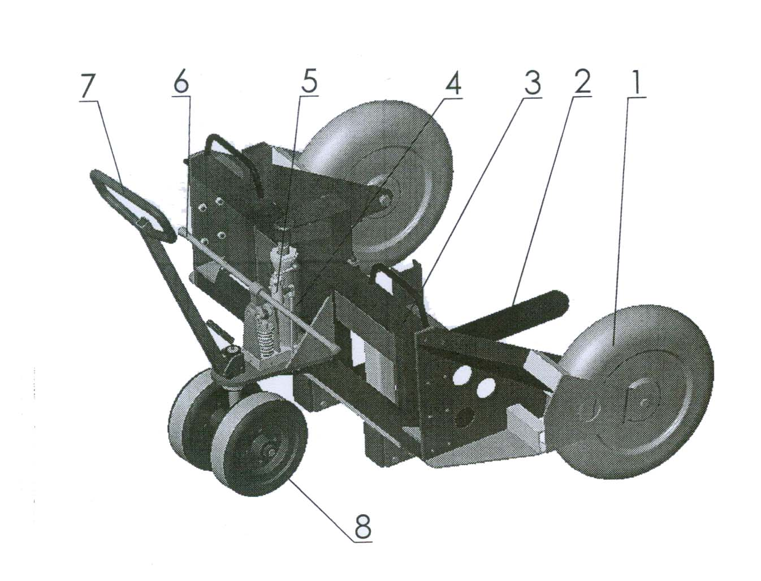
1. Front wheel 2. Fork 3. Chassis
4. Cylinder 5. Release valve 6. Lifting handle
7. Steering handle 8. Steering wheel

Form 1: Specification
Model |  | RP1000
Capacity | Kg | 1000
Max. Lifting Height (H) | mm | 260
Min. Height of Fork (h) | mm | 60
Wheel Base (N) | mm | 860
Width of the forks (E) | mm | 200~700
Length of the fork (L) | mm | 860
Dia. of Front Wheel (D×f1) | mm | 568×143
Dia. of Steering Wheel (D×f1) | mm | 315×100
Min. Turning Radius (R) | mm | 1460
Distance between two wheels (F) | mm | 1250
Overall Length (A) | mm | 1410
Overall Width (B) | mm | 1620
Overall Height (C) | mm | 1300
Net Weight | Kg | 295
Figure 2: Dimensions of the truck
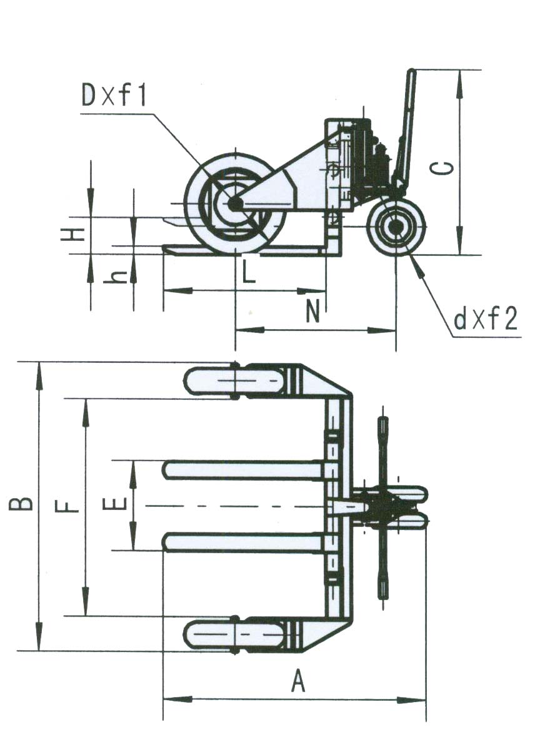

- Steps of Installation

- Turn the two forks (123) to the horizontal position, insert the pin (124), and lock it by the split pin (122).
- Put the wheel brackets (105&135) by the side of the frame (104), use screw (108), washer (107) and nut (106) to fasten them.
- Insert the lifting handle (252) into the base (251), then envelop it by two covers (253).
- Insert the steering handle (301) into the base (319), and then insert pin (305), lock it by retaining ring (306). Connect the hook (303) and handle by spring (302).
Note: Every screw and pin should be lubricated before assembling.

- Operating Instructions
1. Make sure the truck is assembled correctly before operating it.
2. The lifting and lowering is controlled by the control valve. When the valve is at the free position or the handle is turned anti-clockwise, you can lift the fork by pressing the handle up and down. When you turn the valve handle clockwise, the fork descends. Contrarily, when you turn the valve handle anti-clockwise or release the valve, the fork stops lowering.
3. The product is equipped with a double action pump. When the handle is pressed up and down, the piston raises continually. It improves the work efficiency. It is better to operate the truck by two persons to reduce the work intensity. If you operate the truck by one person, you could move the handle to one side to reduce the operating force.
4. When the truck is loaded:
Please put the gravity center of the load as close to the root of the fork as possible.
Avoid the unbalanced load.
Adjust the fork width to proper dimension.
To make sure every part is pressed equably, lift and lower smoothly, move reliably.
5. When the truck is loaded, pay more attention to the pressure of tyre. Whether the pressure is too high or too low, it is harmful for the lifetime of the wheel.
- Safety Guide
  - When operating the truck must be careful, especially at the corner and the slope.
  - Do not put the load on the fork for a long time. When operation is finished, you should lower the fork to the lowest position.
  - Do not lift person.
  - The working temperature is -20℃~45℃. If you want to operate the truck in cold area, must use low-temperature-hydraulic-oil.
  - When it is not used, make sure put it into the garage instead of outdoor.

- Maintenance
  - Maintenance regular and replace the easy-worn parts in time can prolong the lifetime of truck.
  - The truck must be maintained by the professional person.
  - If you want to change parts, please use the parts supplied by manufacturer. Otherwise, it will be harmful for the truck.
  - If the truck needs maintenance, please disassemble the truck as the diagram in this manual.
  - Refer to the parts list in the manual, change the broken parts when maintaining.
  - Daily clean and periodic lubrication is necessary and it will prolong the lifetime of the truck.

Item | Period | Program
Movable Parts | 4 weeks | Add the normal lubricating oil
Hydraulic Parts | 1 year | Do as “change oil”
Wheels | 4 weeks | Check the abrasion. If it is more than 1mm, please change the wheel.  When the wheel pressure less than 200Kpa, please inflate the tyre.  The recommended pressure is 250Kpa.

7. Change Oil
Oil: YA-N46
Volume: 0.5L
First of all make sure the forks are at the lowest position and the oil pan is under the oil cylinder. And then do as follows:
  - Take off the upper plug (1)
  - Take off the lower plug (2)
  - Operate the handle left and right to discharge the oil.
  - Pour the new oil to clean the hydraulic system
  - Assemble the lower plug
  - Pour the clean oil form the upper plug, put on the plug
  - Operate the handle left and right several times, check if there is leaking
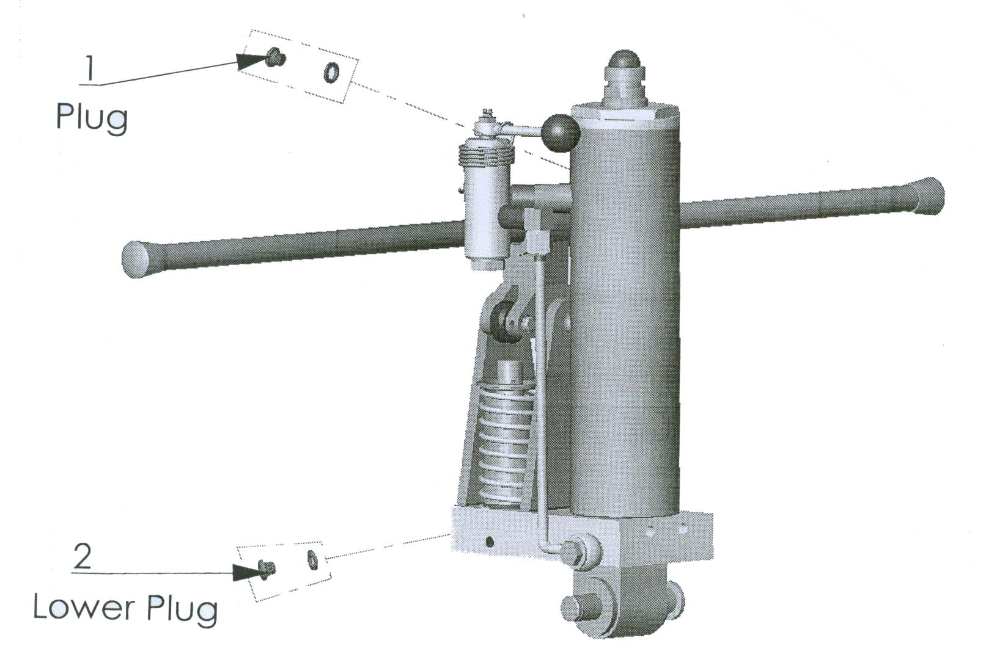
- Hydraulic Circuit

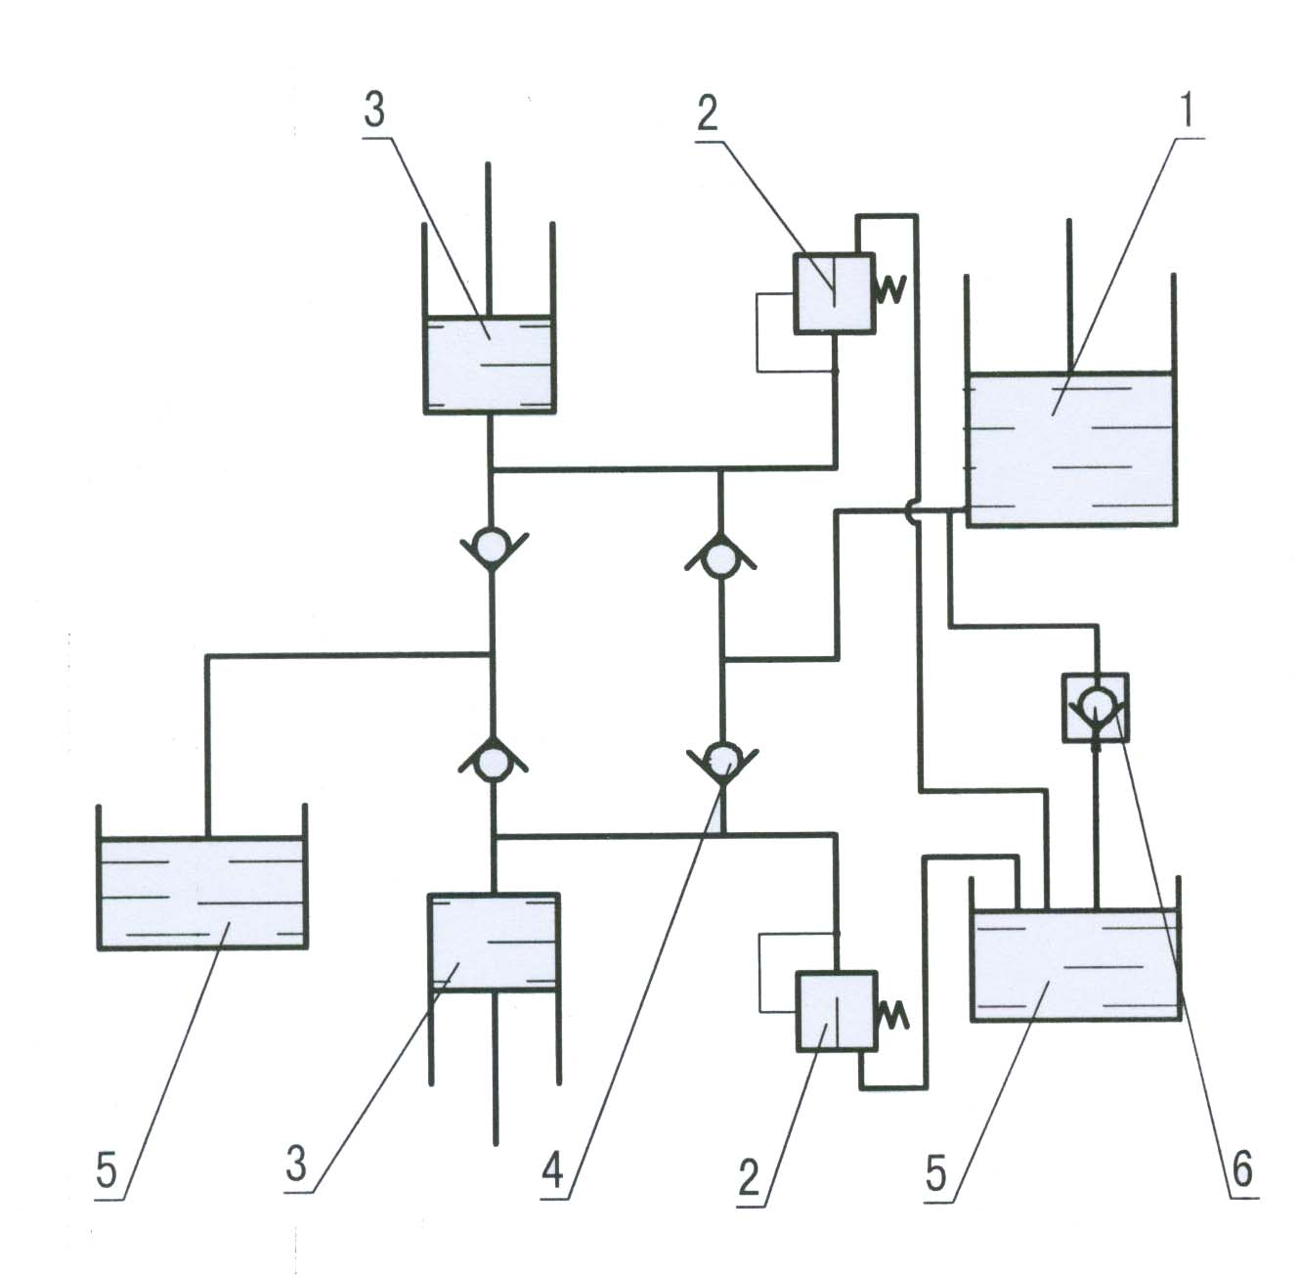
  - Oil tank
  - Safety valve
  - Pump
  - One-way valve
  - Reservoir
  - Manual control valve

- Troubles Shooting

Trouble | Cause | Action
The forks do not lift up when operate the handle up and down. | - Not enough hydraulic oil.  - Leakage  - Safety valve is out of adjustment  - Air comes into the hydraulic oil. | - Add more oil  - Replace seals with new ones  - Adjust the control valve.  - Banish the air.
The forks do not descend or the lowering process is not stable. | - Valve is out of adjustment  - Valve is leaking.  - Seals are too tight | - Adjust the valve.  - Replace seals with new ones  - Check and change
The forks do not lift to max. height. | Not enough hydraulic oil. | Add more oil
Not enough pressure of wheels | Not enough pressure of wheels | Inflate to 250KPa
Tyre is broken | - The pressure is too high.  - Be punctured by something. | Maintain or change tyres

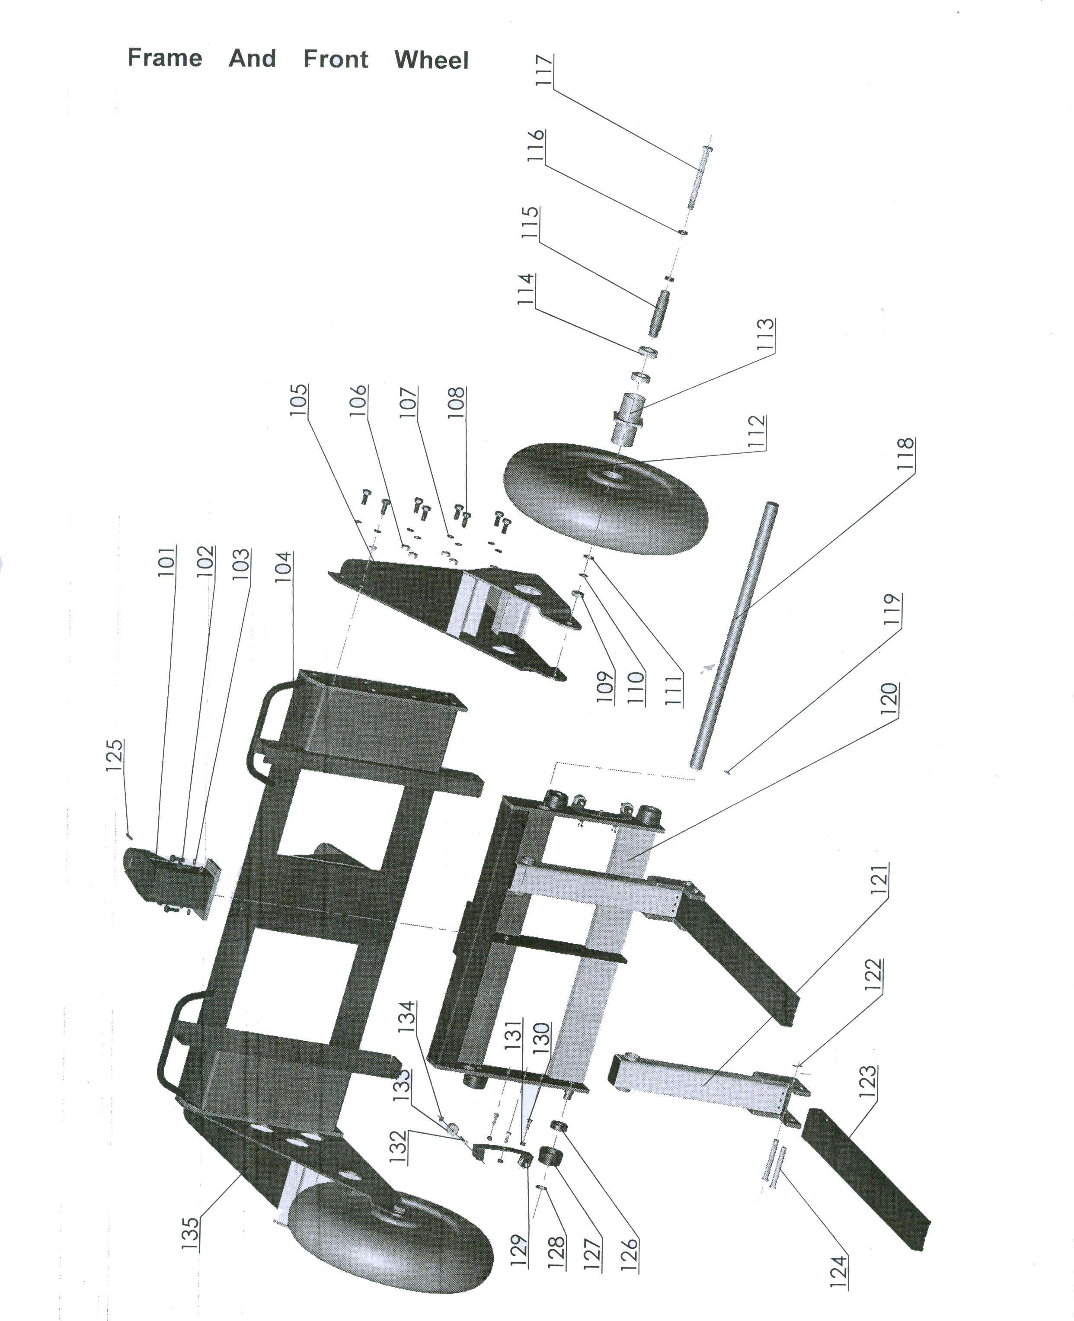

Frame and Front Wheel

No | Description | Qty | No | Description | Qty
101 | Hook | 1 | 119 | Screw M6×10 | 2
102 | Bolt M10×30 | 4 | 120 | Lifting unit | 1
103 | Washer | 4 | 121 | Fork connector | 2
104 | Frame | 1 | 122 | Split pin 4×30 | 4
105 | Bracket (Left) | 1 | 123 | Fork | 2
106 | Nut M12 | 16 | 124 | Axle | 4
107 | Washer 12 | 16 | 125 | Pin | 1
108 | Bolt M12×30 | 16 | 126 | Bearing | 4
109 | Nut M16 | 2 | 127 | Roller | 4
110 | Spring washer 16 | 2 | 128 | Retaining ring | 4
111 | Washer 16 | 2 | 129 | Side wheel unit | 2
112 | Front wheel | 2 | 130 | Bolt M8×20 | 6
113 | Bearing base | 2 | 131 | Nut M8 | 10
114 | Bearing | 4 | 132 | Pin | 4
115 | Bushing | 2 | 133 | Side wheel | 4
116 | Spacer | 4 | 134 | Retaining ring 8 | 4
117 | Bolt M16 | 2 | 135 | Bracket (Right) | 1
118 | Rod | 1

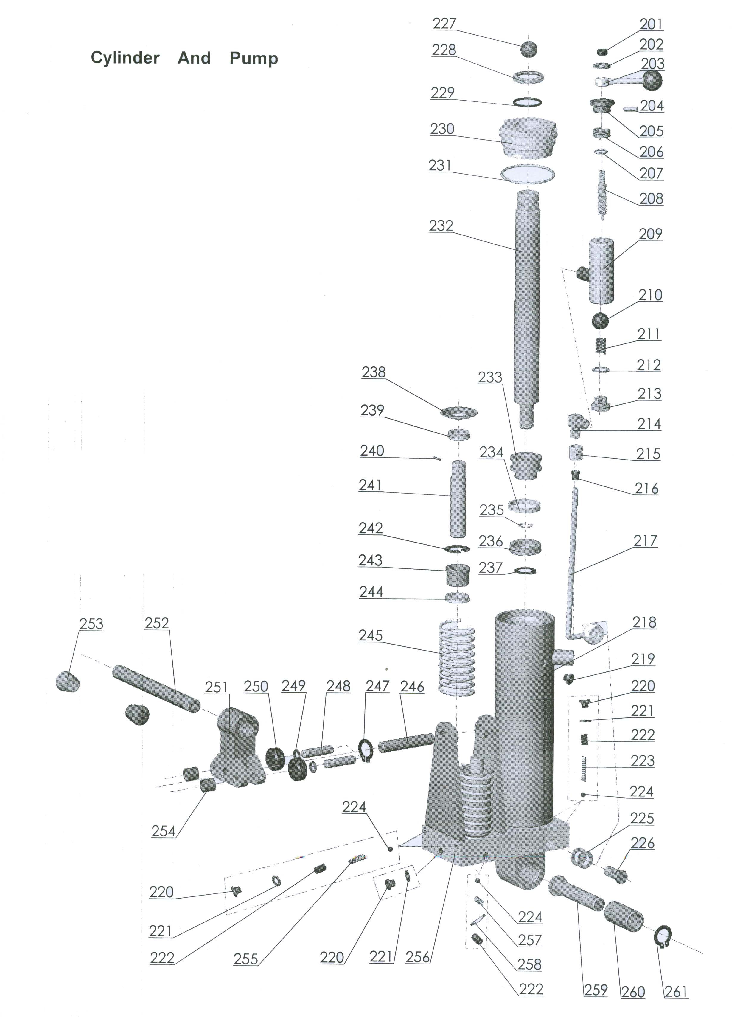
Cylinder and Pump

No | Description | Qty | No | Description | Qty
201 | Nut M8 | 1 | 232 | Piston rod | 1
202 | Washer 8 | 1 | 233 | Piston | 1
203 | Control valve | 1 | 234 | Guiding belt | 1
204 | Screw M5×10 | 1 | 235 | O-ring | 1
205 | Spring base | 1 | 236 | U-ring | 1
206 | Spring | 1 | 237 | Retaining ring | 1
207 | O-ring | 1 | 238 | Spring cover | 2
208 | Needle | 1 | 239 | U-ring | 2
209 | Valve body | 1 | 240 | Axle | 2
210 | Steel ball | 1 | 241 | Rod | 2
211 | Spring | 1 | 242 | Ring 20 | 2
212 | Washer 10 | 2 | 243 | Guiding bushing | 2
213 | Plug | 1 | 244 | U-ring | 2
214 | Oil joint | 1 | 245 | Spring | 2
215 | Nut | 1 | 246 | Fixed axle | 1
216 | Bushing | 1 | 247 | Retaining ring 16 | 1
217 | Oil tube | 1 | 248 | Press wheel axle | 2
218 | Reservoir | 1 | 249 | Retaining ring 12 | 2
219 | Rubber plug | 1 | 250 | Press wheel | 2
220 | Plug M10×1 | 5 | 251 | Rod base | 1
221 | Seal ring 10 | 5 | 252 | Lifting handle | 1
222 | Screw | 6 | 253 | Handle cover | 2
223 | Spring | 2 | 254 | Bushing | 2
224 | Steel ball Ф7 | 6 | 255 | Spring | 2
225 | Washer | 2 | 256 | Baseboard | 1
226 | Screw | 1 | 257 | Spring | 2
227 | Steel ball Ф24 | 1 | 258 | Seal ring 10 | 2
228 | Dust proof ring | 1 | 259 | Axle | 1
229 | O-ring | 1 | 260 | Bushing | 1
230 | Cylinder cover | 1 | 261 | Retaining ring | 1
231 | O-ring | 1
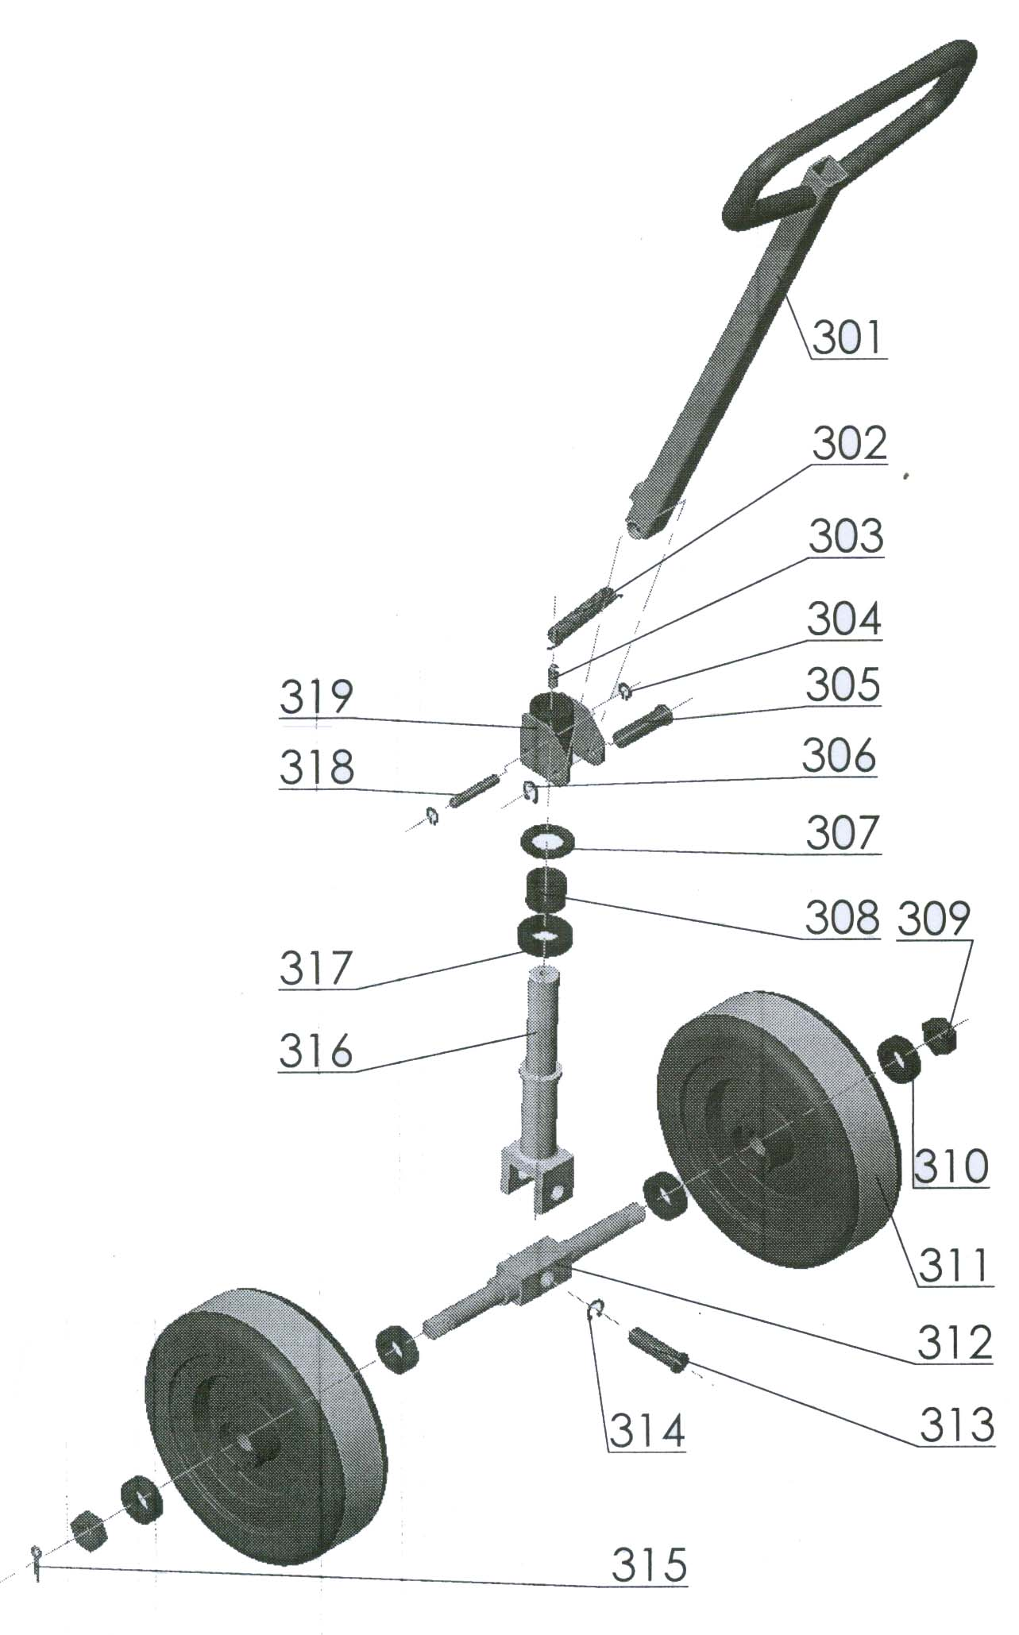

Steering Wheel and Steering Handle

No | Description | Qty | No | Description | Qty
301 | Handle | 1 | 311 | Steering wheel | 2
302 | Spring | 1 | 312 | Wheel axle | 1
303 | Hook | 1 | 313 | Axle | 1
304 | Retaining ring 12 | 2 | 314 | Retaining ring | 1
305 | Axle | 1 | 315 | Split pin | 2
306 | Retaining ring | 1 | 316 | Spindle | 1
307 | Washer | 1 | 317 | Bearing | 1
308 | Ring | 1 | 318 | Pin | 1
309 | Nut 16 | 2 | 319 | Handle base | 1
310 | Bearing | 4

