Instruction Manual

M100 M200

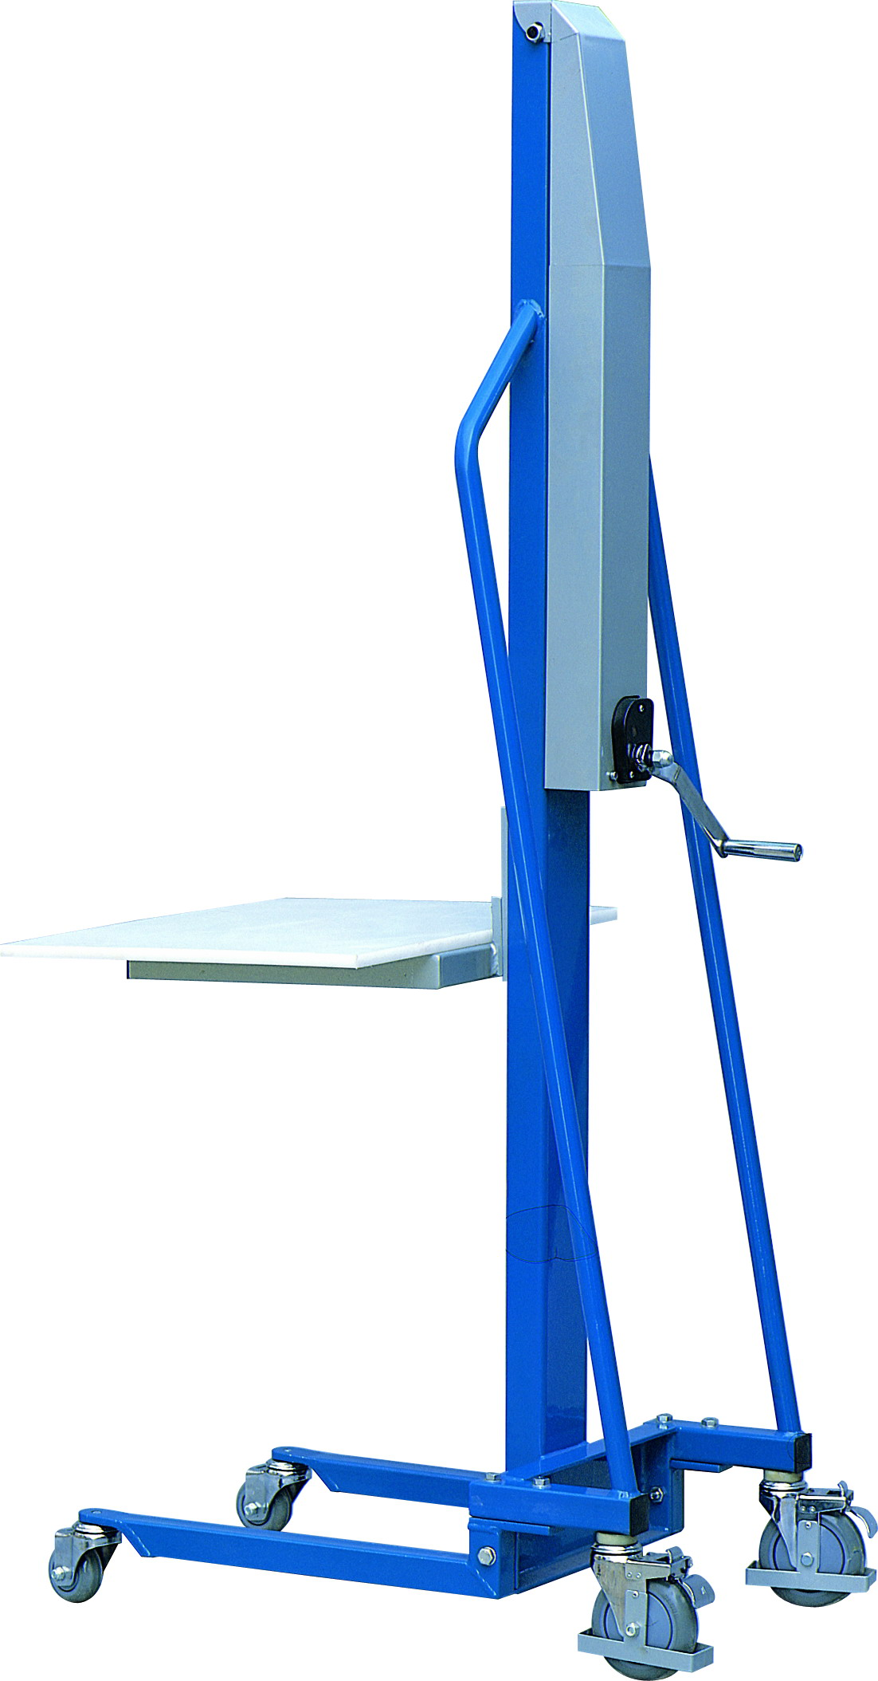

Note: The Owner/Operator must read carefully and understand all the information presented here before operation.

Content
A. Dimensions & Parameter Chart
B. Part Name
C. Warnings
D. Operation Guide
E. Daily Maintenance & Periodic Inspection
F. Trouble Shooting
G. Explosive Graphics
H. Chart of Parts

Thank you for your using this series of elevators.

This manual describes right operation method for ensuring safety and tile right ways of maintenance, which prolongs the working life of the equipment. The operator must read carefully and understand all the information presented here and be trained before operation, or it will cause personal injury or elevator damaging.
This series of elevators are mainly applied for the use of transition, elevation and piling for goods with a certain weight and different shape, or for the occasion of taking off some goods from a certain height fork transition.
That the light and delicate appearance, quick and convenient operation together with lots of accessories make the series of elevator be applied extensively in various kinds of factories, emporiums and warehouses, and become highly reliable under-worker with only little maintenance.

Dimensions & Parameter Chart

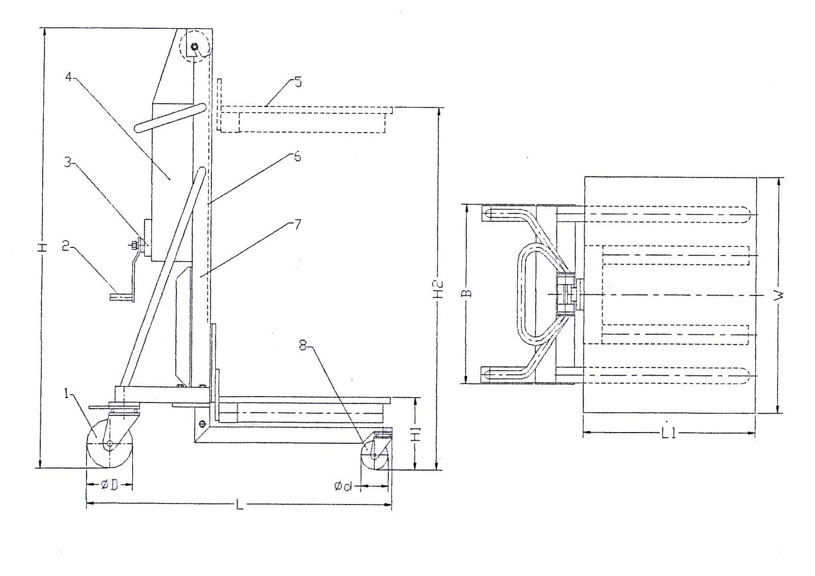

Type | M100 | M200
Load Capacity kg | 100 | 200
Height Min. H1 mm | 130 | 130
Height Max. H2 mm | 1500 | 1500
Platform L1×W mm | 470×600 | 470×600
Dimension L×W×H mm | 840×600×1830 | 840×600×1920
Front Wheel Dia. d mm | Ø75 | Ø75
Rea Wheel Dia. D mm | Ø125 | Ø125
Weight kg | 48 | 70

B. Part Name
1. Rear Wheel
2. Handle
3. Ratchet transmission structure
4. Guard
5. Platform (several accessories available)
6. Wire rope
7. Pole
8. Front wheel

C. Warnings
1. Not allowed to be used on slanting floor, course and uneven ground and soft land.
2. Not allowed for overloading, and it is necessary to keep a uniformity of load.
3. Special attention to transit round and roll-able articles for safety both when loading and unloading.
4. Keep the platform or fork (accessory) lowest positioned, stable and slow moving the elevation cart when heavy loaded.
5. When the platform or fork (accessory) lowers to the end, not to turn the handle counter-wise continuously, or the wire rope will be too loosened to keep in the pulley and that is dangerous and trouble causing.
6. When the loaded platform or fork (accessory) elevated to a relatively prominent height, please take care to ensure the vehicle stable and safe.

D. Operation Guide
1. Lock up the wheel before up/down operation or loading or unloading.
2. Validate the wire rope seated in the pulley, connecting bolts fast and fixed and safe.
3..Turn the handle clock-wise, platform or fork (accessory) goes upward up to the high-max, stop turning the handle, the platform or fork (accessory) shall stop and keep up at any position without descending.
4. Turn the handle counter clock-wise, platform or fork (accessory) lowers to the end, not to turn the handle continuously, lest the wire rope shall escape.

E. Daily Maintenance & Periodic Inspection
1. Check daily the wire rope, pulley, roller, front and rear truckles and other structure parts for wearing, casting, and deformation.
2. Once each three months for a check of lubricating-wearing for ratchet wheel structure and parts.
3. Once each three months for an oiling and greasing of ratchet structure, gear structure and handle structure.
4. Check and ensure all connecting bolts are fast and fixed.

F. Trouble Shooting
SN | Item | Cause | Treatment
1 | No elevation for platform  or fork (accessory) | 1. Wire fall-off | Check adjusting, connect fast
1 | No elevation for platform  or fork (accessory) | 2. Wire flossing in disk | Re-tidying
1 | No elevation for platform  or fork (accessory) | 3. Other particle lock | Clear away
2 | Platform or fork (acc.)  Slipping after raised | - Ratchet structure  Damage | Check, turn-over
2 | Platform or fork (acc.)  Slipping after raised | - Copper friction  washer wearing-off | Check, adjust, turn-over
3 | Platform or fork (acc.)  idle for descending or  descending unevenly | - Ratchet structure  damage | Check, turn-over
3 |  | 2. Other particle lock | Clear away

G. Explosive Graphics
- 100kg Single Pole Manual Elevator Explosive Graphics

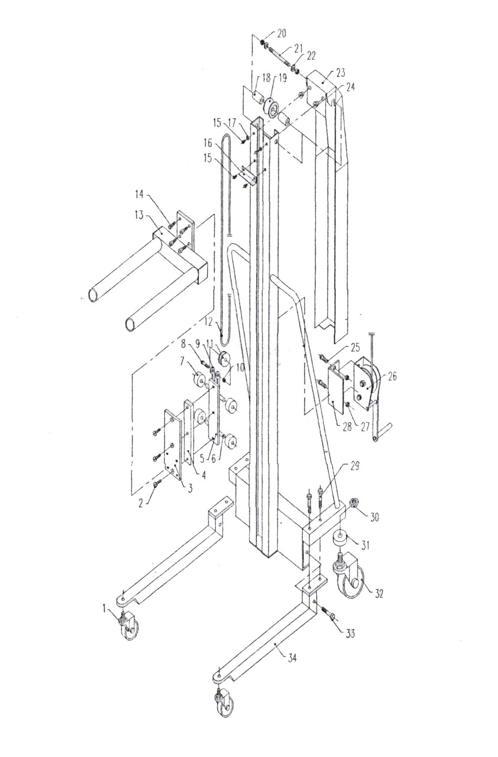

SN | Item | Q’ty | SN | Item | Q’ty
1 | Front Wheel | 2 | 2 | Sunk Bolt | 3
3 | Connecting Board | 1 | 4 | Guiding Slipper | 1
5 | Roller Fixed Board | 1 | 6 | Trolley Shaft | 2
7 | Trolley | 4 | 8 | Hex. Screw Bolt | 1
9 | Connecting Block | 1 | 10 | Locking Nut | 1
11 | Traveling Block | 1 | 12 | Wire Rope | 1
13 | Fork (Dual Fork) | 1 | 14 | Inner Hex. Bolt | 4
15 | Inner Hex. Bolt | 4 | 16 | Limit Block | 1
17 | Washer | 2 | 18 | Interval Ring | 2
19 | Crown Block | 1 | 20 | Locking Nut | 2
21 | Double-Edged Bolt | 1 | 22 | Washer | 2
23 | Guard | 1 | 24 | Lining | 2
25 | Hex. Screw Bolt | 2 | 26 | Ratchet Structure | 1
27 | Locking Nut | 2 | 28 | Fixing Racket | 1
29 | Hex. Screw Bolt | 4 | 30 | Locking Nut | 2
31 | Washer | 2 | 32 | Rear Wheel | 2
33 | Hex. Screw Bolt | 2 | 34 | Front Wheel Fork | 2

- 100kg Single Pole Manual Elevator Ratchet Structure Explosive graphics

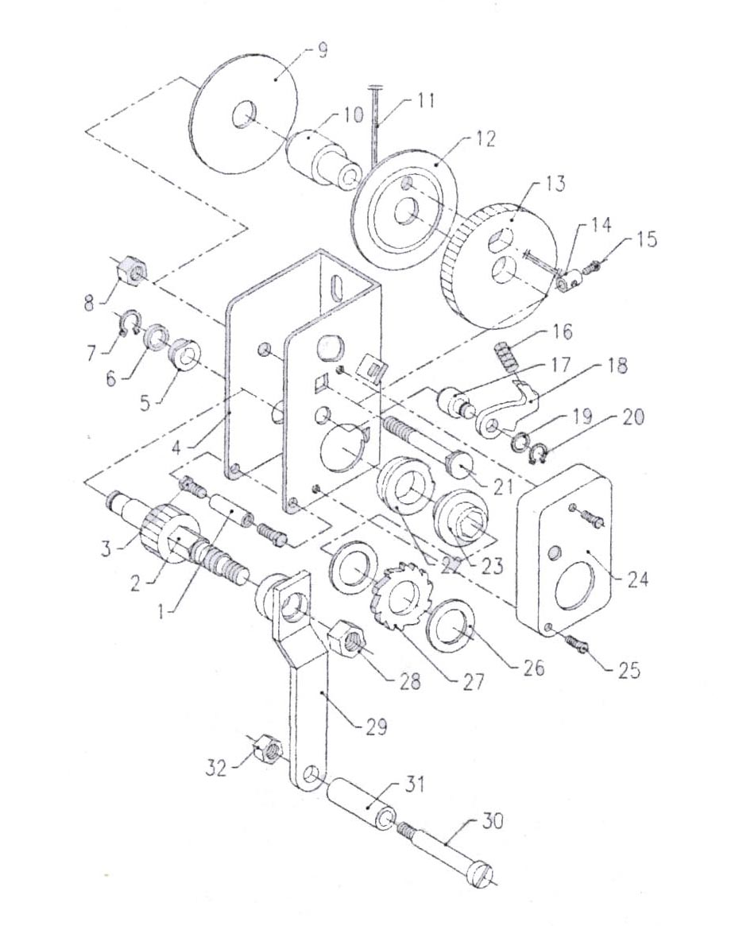

SN | Item | Q’ty | SN | Item | Q’ty
1 | Prop | 1 | 17 | Pin Shaft | 1
2 | Hex. Gear Shaft | 1 | 18 | Pallet Sheet | 1
3 | Hex. Bolt | 2 | 19 | Washer | 1
4 | Fixing Racket | 1 | 20 | Ringent Shield Ring | 1
5 | Limit Ring | 1 | 21 | Bolt | 1
6 | Washer | 1 | 22 | Limit Ring | 1
7 | Ringent Shield Ring | 1 | 23 | Inner Hex. Lining | 1
8 | Locking Nut | 1 | 24 | Petty Guard | 1
9 | Baffle | 1 | 25 | Hex. Bolt | 2
10 | Interval Ring | 1 | 26 | Copper Washer | 2
11 | Wire Rope | 1 | 27 | Pallet Sheet | 1
12 | Baffle | 1 | 28 | Lid Nut | 1
13 | Big Gear | 1 | 29 | Handle | 1
14 | Clamp | 1 | 30 | Handle Bolt | 1
15 | Hex. Bolt | 1 | 31 | Sleeve | 1
16 | Spring | 1 | 32 | Locking Nut | 1

- 200kg Single Pole Manual Elevator Explosive Graphics

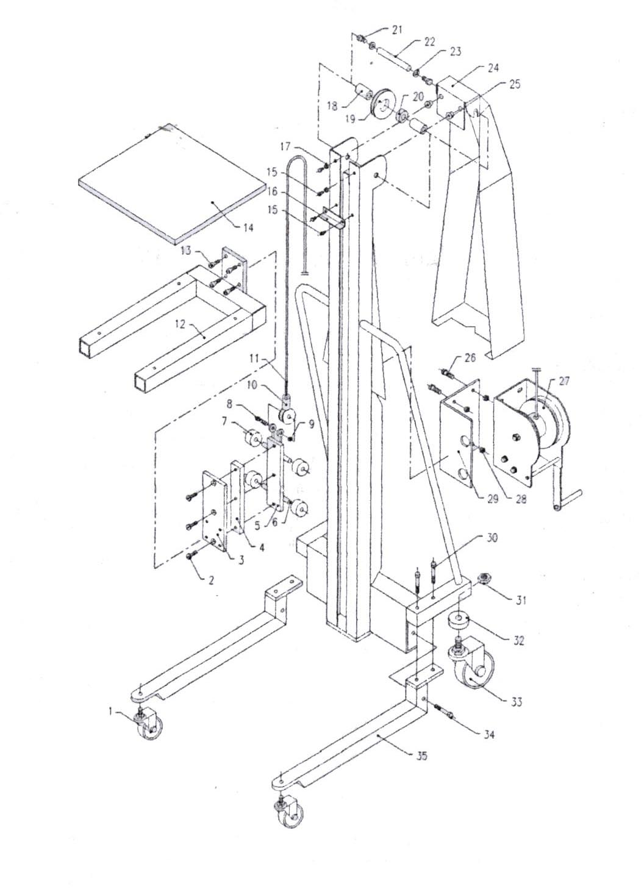

SN | Item | Q’ty | SN | Item | Q’ty
1 | Front Wheel | 2 | 2 | Sunk Bolt | 3
3 | Connecting Board | 1 | 4 | Guiding Slipper | 1
5 | Roller Fixing Board | 1 | 6 | Trolley Shaft | 2
7 | Roller | 4 | 8 | Hex. Bolt | 1
9 | Locking Nut | 1 | 10 | Wire Clamp | 1
11 | Wire Rope | 1 | 12 | Fixed Racket | 1
13 | Inner Hex. Bolt | 4 | 14 | Working Platform | 1
15 | Hex. Bolt | 4 | 16 | Limit Shield | 1
17 | Washer | 2 | 18 | Interval Ring | 2
19 | Crown Block | 1 | 20 | Bearing | 1
21 | Locking Nut | 2 | 22 | Crown Block Shaft | 1
23 | Washer | 2 | 24 | Guard | 1
25 | Lining | 2 | 26 | Hex. Bolt | 4
27 | Ratchet Structure | 1 | 28 | Locking Nut | 4
29 | Fixed Racket | 1 | 30 | Hex. Bolt | 4
31 | Locking Nut | 2 | 32 | Washer | 2
33 | Rear Wheel | 2 | 34 | Hex. Bolt | 2
35 | Front Wheel Fork | 2

- 200kg Single Pole Manual Elevator Ratchet Structure Explosive Graphics

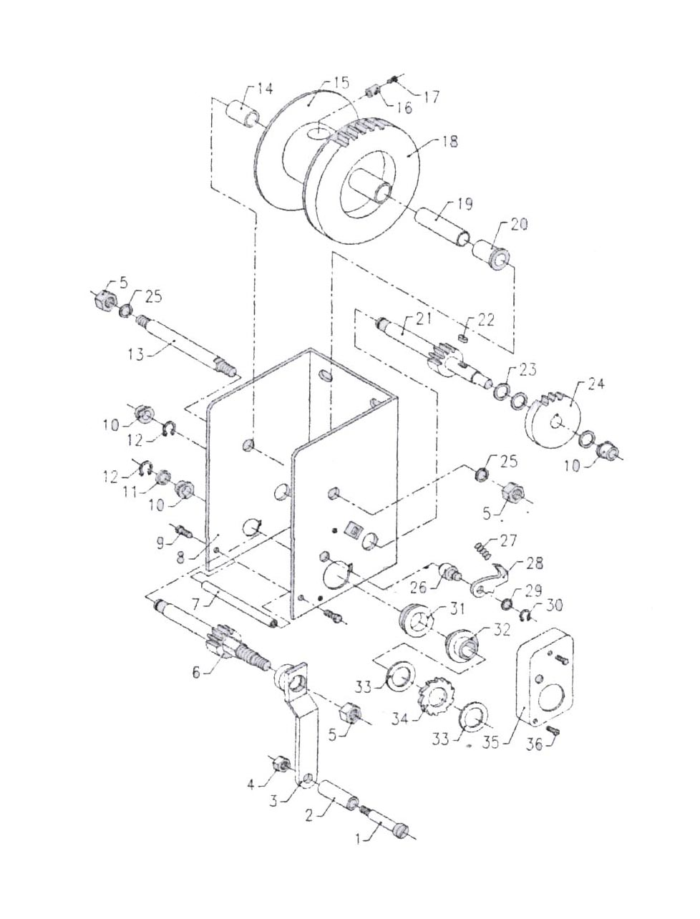

SN | Item | Q’ty | SN | Item | Q’ty
1 | Handle Bolt | 1 | 19 | Interval Ring | 1
2 | Lining | 1 | 20 | Lining | 1
3 | Handle | 1 | 21 | Gear Shaft | 1
4 | Locking Nut | 1 | 22 | Plain Pin | 1
5 | Locking Nut | 1 | 23 | Washer | 3
6 | Hex. Gear Shaft | 1 | 24 | Gear | 1
7 | Prop | 1 | 25 | Washer | 2
8 | Fixed Racket | 1 | 26 | Pin Shaft | 1
9 | Hex. Bolt | 2 | 27 | Spring | 1
10 | Limit Lining | 3 | 28 | Pallet Sheet | 1
11 | Washer | 1 | 29 | Washer | 1
12 | Ringent Shield Ring | 2 | 30 | Ringent Shield Ring | 1
13 | Roller | 1 | 31 | Limit Ring | 1
14 | Lining | 1 | 32 | Inner Hex. Lining | 1
15 | Wire Baffle | 2 | 33 | Washer | 2
16 | Wire Clamp | 1 | 34 | Ratchet Wheel Sheet | 1
17 | Hex. Bolt | 1 | 35 | Petty Guard | 1
18 | Big Gear | 1 | 36 | Hex. Bolt | 2

