Instruction Manual
High Lift Hand Truck

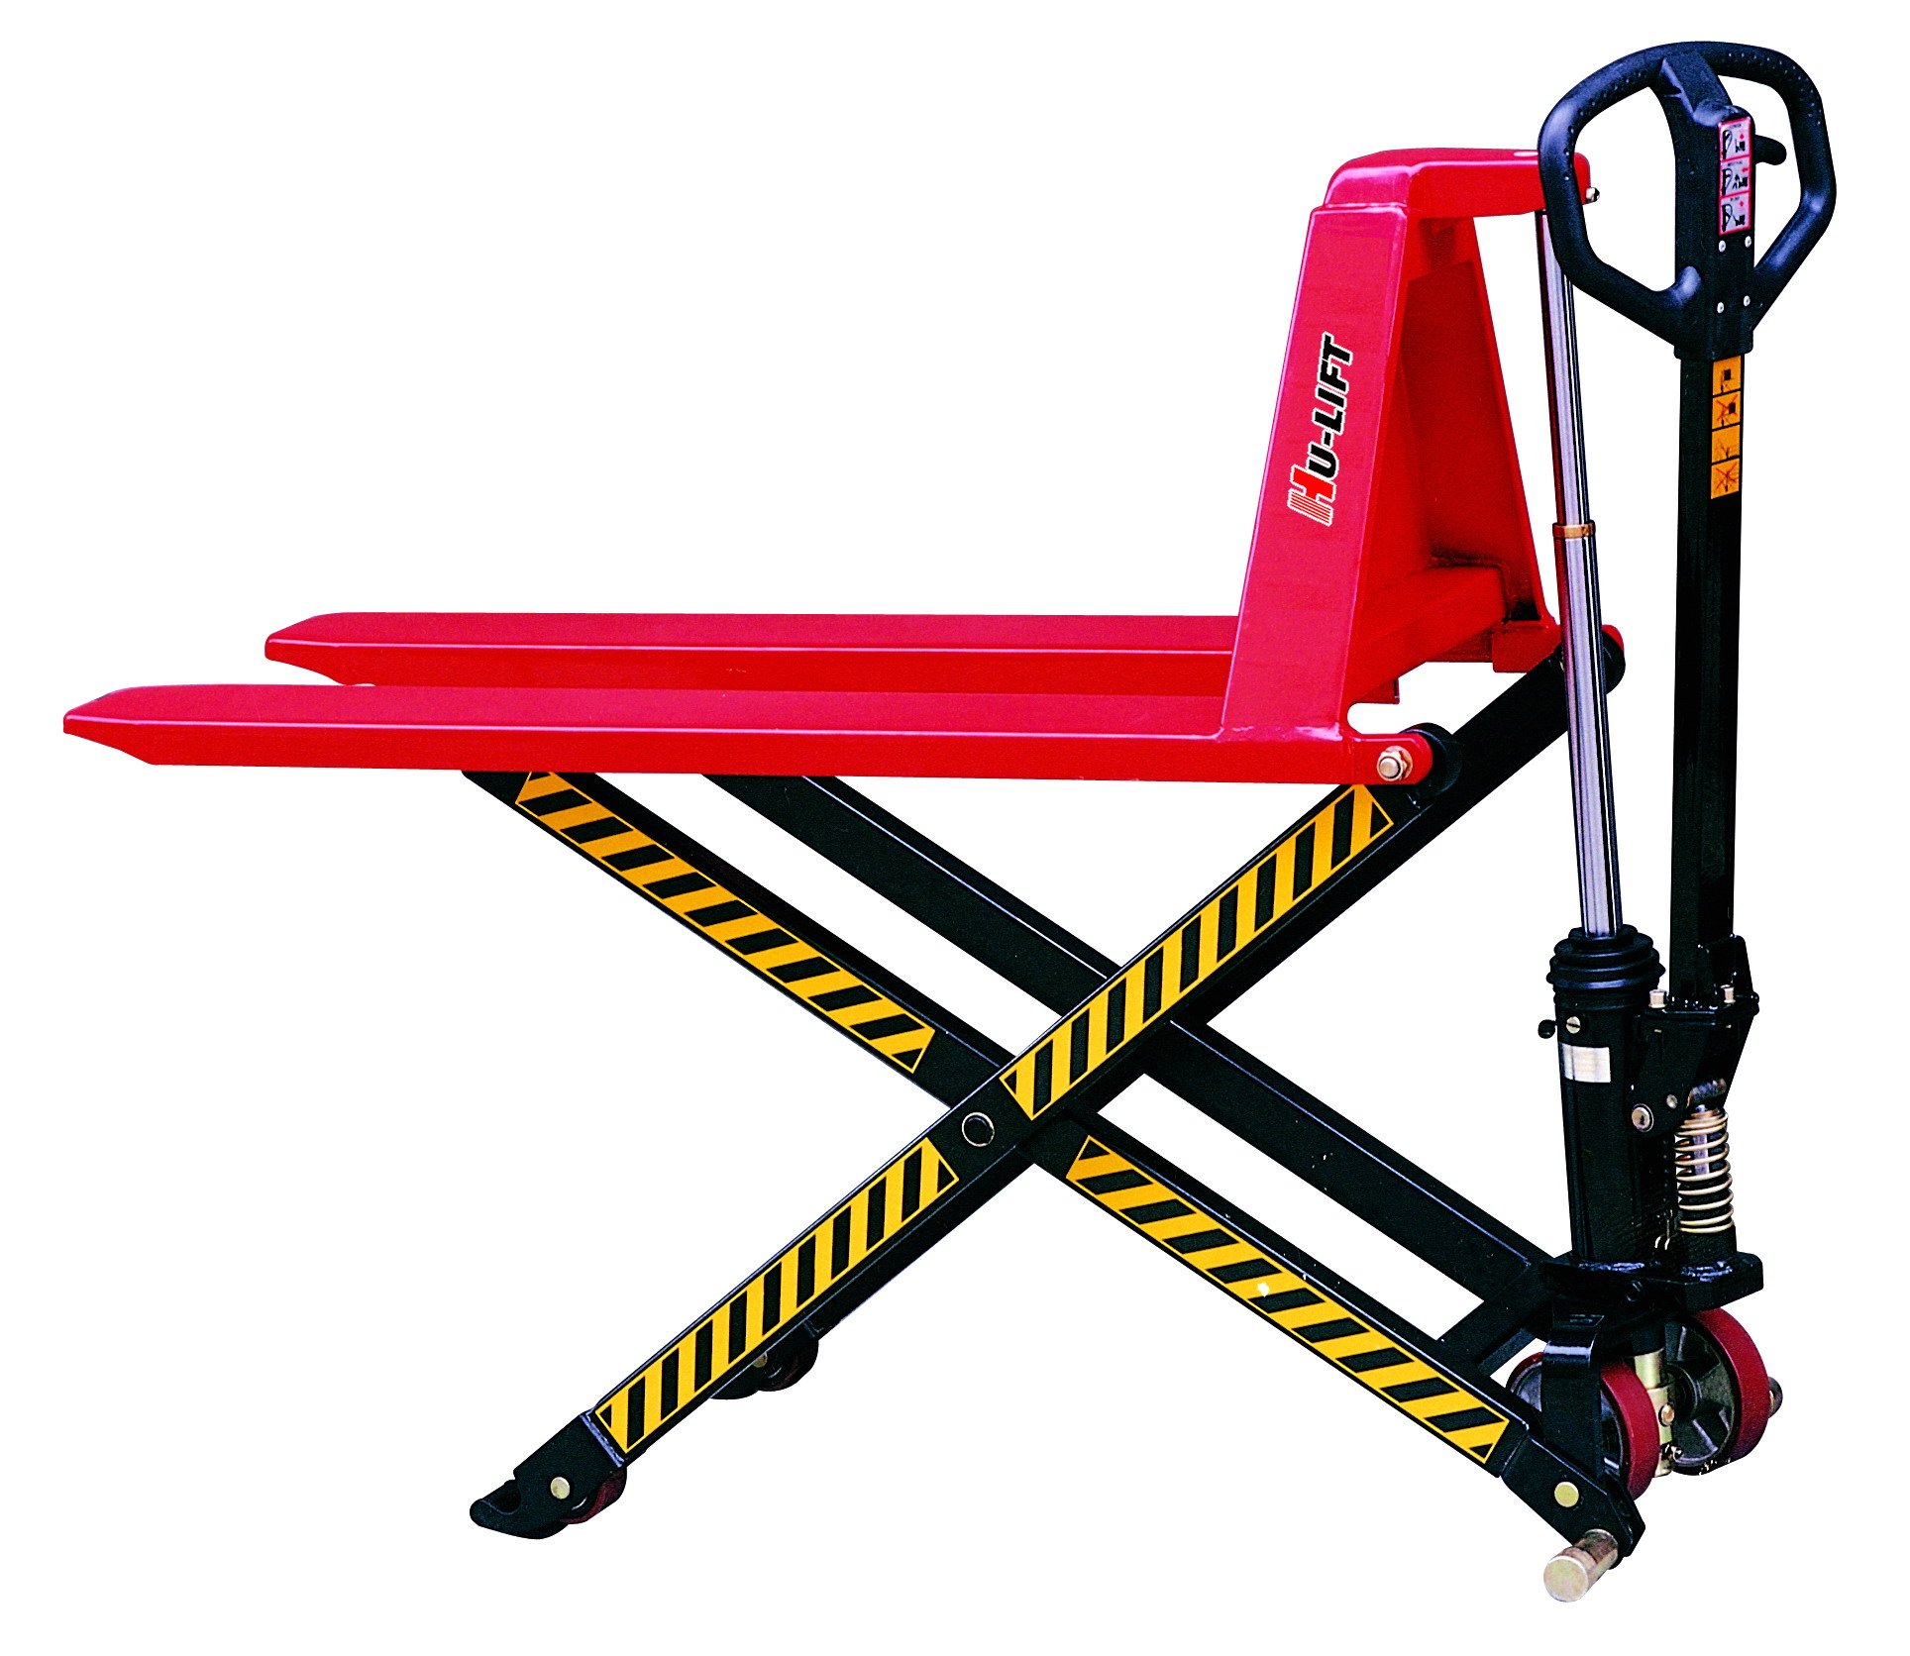

Note: The Owner/Operator must read carefully and understand all the information presented here before operation.

CONTENT
1. | Specification…………………………………………. |  | 2
2. | Safety Instructions…….…………………………….. |  | 2
3. | Installation & Adjustment…………………………… |  | 3
 | 3.1 | Screw (part No.158)………….…………………….. | 3
 | 3.2 | Handle……………………………………………….. | 3
4. | Trouble Shooting Guide………………………….…. |  | 7
5. | Exploded View & Part List………………………….. |  | 8
 | 5.1 | Fork Exploded View ……………………………. | 8
 | 5.2 | Pump Assembly Exploded View……….………….. | 11

THANK YOU FOR USING THIS HIGH LIFT HAND TRUCK. FOR YOUR SAFETY AND CORRECT OPERATION, PLEASE CAREFULLY READ THIS INSTRUCTION BEFORE USING IT.

NOTE: All of the information reported herein is based on data available at the moment of printing. The factory reserves the right to modify its own products at any moment without notice and incurring in any sanction. So it is suggested to always verify possible updates.

1. SPECIFICATIONS
Model | JL5210 | JL6810 | JL5215 | JL6815
Rated Capacity | 1000 kg |  | 1500 kg
Max. Lifting Height | 800 mm
Min. Fork Height | 85 ±2 mm
Fork Length | 1140 mm |  | 1100mm
Fork Overall Width | 520mm | 680mm | 520mm | 680mm
N.W. | 106 kg | 112kg | 118 kg | 125kg
NOTE:
Two speeds (fast and slow) can be automatically changed as the load of more than 150kgs.

2. SAFETY INSTRUCTIONS
- The truck shall be used in accordance with the instructions manual.
- Don’t put the hand & foot under the fork at any time.
- Don’t work on the slope surface.
- Quick lifting is prohibited for loads of more than 150 kgs. Any manipulation of the pressure relief valve is strictly prohibited. All assembling, adjusting and maintenance shall only be done by industrial mechanics trained people. These people must be familiar with all safety regulations of European and national where the item is in use relating to the operation and maintenance of pedestrian controlled industrial trucks.
- Load should be put on the fork center. Side-load is strictly prohibited.
- The truck shall not be used to transport persons.
- It is recommended to the driver to wear security shoes.
- No modifications shall be carried out which adversely affect the compliance of the truck with prEN 1757-4.

3.INSTALLATION & ADJUSTMENT
3.1 Screw (part No.158)
- To prevent oil leaking from oil tank during transportation, Air Screw (part No.158) is replaced with Oil-sealing Screw in the factory. But it has to be replaced back when you put this truck in use.
- How to change: Screw out Oil-sealing Screw, then screw in Air Screw, thus keep oil tank always connecting with atmosphere.

3.2 Handle
During transportation, the handle is disassembled from the truck and packed separately. It has to be assembled back and adjusted properly and carefully before use.
- Handle installation:
- Take 3 pieces of M10 Nut (No.186) & Hex Wrench from spare parts bag. Select handle to match the truck with the same fitting numbers.
- Assemble the handle on the Handle Base (No.181) with 3 pieces of M10 Nut & Spring Washer tightly.
- Put the chain’s Eye Bolt (No.110) in the slot at the front end of Pendulum Arm (No.112).

B. Handle adjustment
- There are 3 different positions with different functions for the Release Lever
(Part No.106)
Position I: Lifting for fork.
Position II: Neutral for fork.
Position III: Descending for fork.
Release Lever
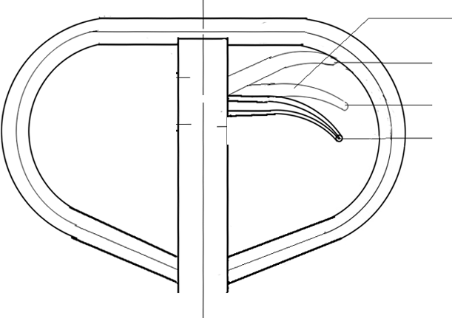(No.106)
III
II
I

Picture 1

- Test different functions by putting the Release Lever in 3
different positions respectively.
If it does not function properly, then adjusting Lock Nut (No.113) by following process. See picture 2.

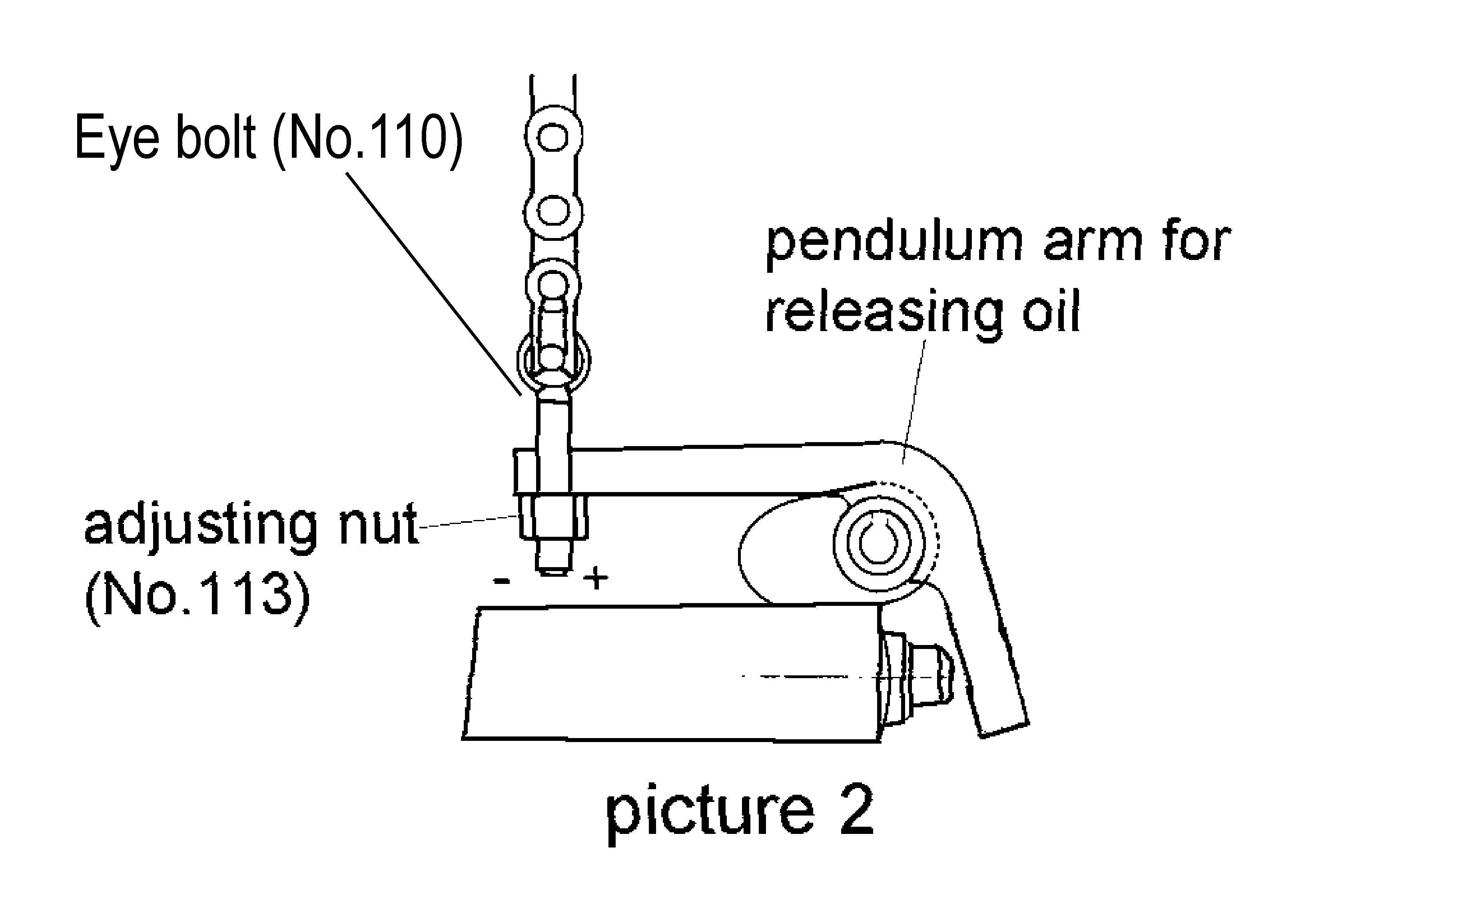
Problems | Turning direction of Lock Nut
Fork not lifted up | -  (counter-clockwise)
Fork not lowering down | +  (clockwise)

- When to add oil
See Picture 3.

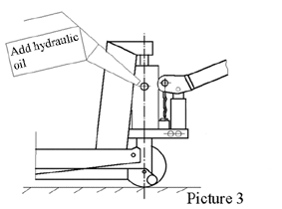

If the fork can’t be pumped up to its rated highest position, you may have to add hydraulic oil into the oil tank. The hydraulic fluid to be used must have a quality of ISO VG22 or equivalence.
Mixing of different fluids is prohibited!

4. TROUBLE SHOOTING GUIDE
Items | Symptom | Possible Cause | Aliments
1 | Fork cannot be pumped up. | - Low oil level in oil tank.  - Exist air in the hydraulic system.  - Pendulum arm nut is not adjusted properly. | - Add proper hydraulic oil.  - Fast operating the handle for several times. Bleed the system.  - Adjust pendulum arm screw.(see picture 2)
2 | Fork can’t be released down. | Fork blocked.  - Pendulum arm nut not adjusted properly. | - Check and remove the block.  - Adjust pendulum arm nut properly.  (See picture 2.)
3 | Fork can’t be pumped up to rated highest position. | Oil is not enough. | Add hydraulic oil.  (See picture 3.)
4 | Neutral has no difference between position I and position II of release lever | Pendulum arm nut is not adjusted properly. | Adjust pendulum arm nut.  (See picture 2)

5. EXPLODED VIEW & PART LIST
5.1 Fork Exploded View

Part List

Item No. | Description | Qty
1 | Fork | 1
2 | Screw | 1
3 | Nut | 1
4 | Power unit | 1
5 | Hold yoke | 1
6 | Wheel yoke | 1
7 | Centrifugal axle | 2
8 | Spacer | 2
9 | Steering wheel | 2
10 | Snap ring | 8
11 | Pin | 2
12 | Snap ring | 12
13 | Bush | 2
14 | Leg | 2
15 | Leg | 1
16 | Bush | 2
17 | Pin | 2
18 | Washer | 2
19 | Nut | 2
20 | Washer | 8
21 | Ball bearing | 8
22 | Front wheel | 2
23 | Wheel axle | 2
24 | Roller | 4
25 | Bush | 2
26 | Washer | 4
27 | Spring washer | 2
28 | Lock Nut | 2
31 | Screw | 1
32 | Nut | 1
30 | Steering wheel assembly  (incls.6,9,10,21,31,32) | 1

5.2 Pump Assembly Exploded View

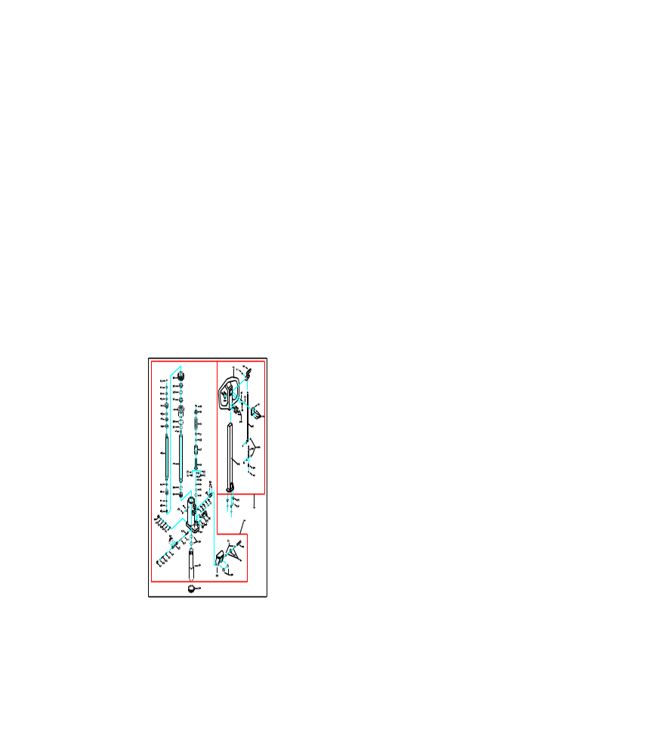

Parts List

Item No. | Description | Qty
102 | Handle Tube | 1
104 | Pin | 1
105 | Roller | 1
107 | Release Rod | 1
108 | Chain Connector | 3
109 | Chain | 1
110 | Eye Bolt | 1
112 | Pendulum Arm | 1
113 | Pendulum Arm Nut | 1
117 | Pin | 1
119 | Seat | 1
120 | Screw | 1
121 | Gasket | 1
122 | Spring | 1
123 | Release Valve | 1
124 | Ball | 2
125 | Valve Insert | 1
126 | O-ring | 4
127 | Spring | 1
128* | O-ring | 1
129 | Release Indicator | 1
136 | Scraper Ring | 1
137 | O-ring | 1
138 | Y-ring | 1
144 | Ball | 1
145 | Spring | 1
146 | Adjusting Screw | 1
147 | Sealing Screw | 1
148 | Screw | 1
149 | Snap Ring | 1
150 | O-ring | 2
153 | O-ring | 1
155 | O-ring | 1
157 | Screw | 2
158 | Air Screw | 1
159 | Cylinder | 1
160 | Pump Housing | 1
161 | Thrust Bearing | 1
162 | Ball | 1
163 | Snap Ring | 1
164 | Washer | 1
170 | Bush | 2
171 | Piston | 1
172 | Screw | 1
173 | Axle | 1
174 | Gasket | 1
175 | Lock Screw | 1
176 | Rubber Sleeve | 1
177 | Washer | 1
179 | Bush | 1
180 | Adjusting Screw | 1
181 | Handle Base | 1
182 | Adjusting Washer | 1
183 | Rubber Sleeve | 1
185 | Hex Screw | 3
186 | Spring Washer | 3
190 | Copper Piston | 1
191 | Snap Ring | 1
192 | Snap Ring | 2
100 | Pin | 6
99 | Screw | 4
98 | Cover | 1
97 | Pin | 1
96 | Ball | 1
95 | Spring | 1
94 | Release Lever | 1
93 | Pin | 1
92 | Handle | 1
91 | Pin | 1
90 | Washer | 1
89 | Spring | 1
88 | Scraper Ring | 1
87 | Y-Ring | 1
85 | Pump | 1
84 | Plunger | 1
83 | Ball | 2
82 | Spring | 2
81 | Spring | 1
80 | O-ring | 1
79 | Screw | 1
78 | O-ring | 1
76 | O-ring | 1
75 | Gasket | 1
74 | Washer | 1
73 | Spacer | 2
72 | Spring | 1
71 | Washer | 1
70 | Bush | 2
301 | Bush | 1
302 | Back-Up ring | 1
303 | Y-ring | 1
304 | Bush | 1
305 | Snap ring | 1
306 | Piston rod | 1
307 | Cylinder head | 1
308 | Cylinder | 1
300 | Pump unit | 1
50 | Handle assembly | 1
Remark:
Parts with “*” mark are supplied together with the High Lifter and packed in the poly bags.

