INSTRUCTION MANUAL

HAND STACKER PA0515

Capacity 500kg

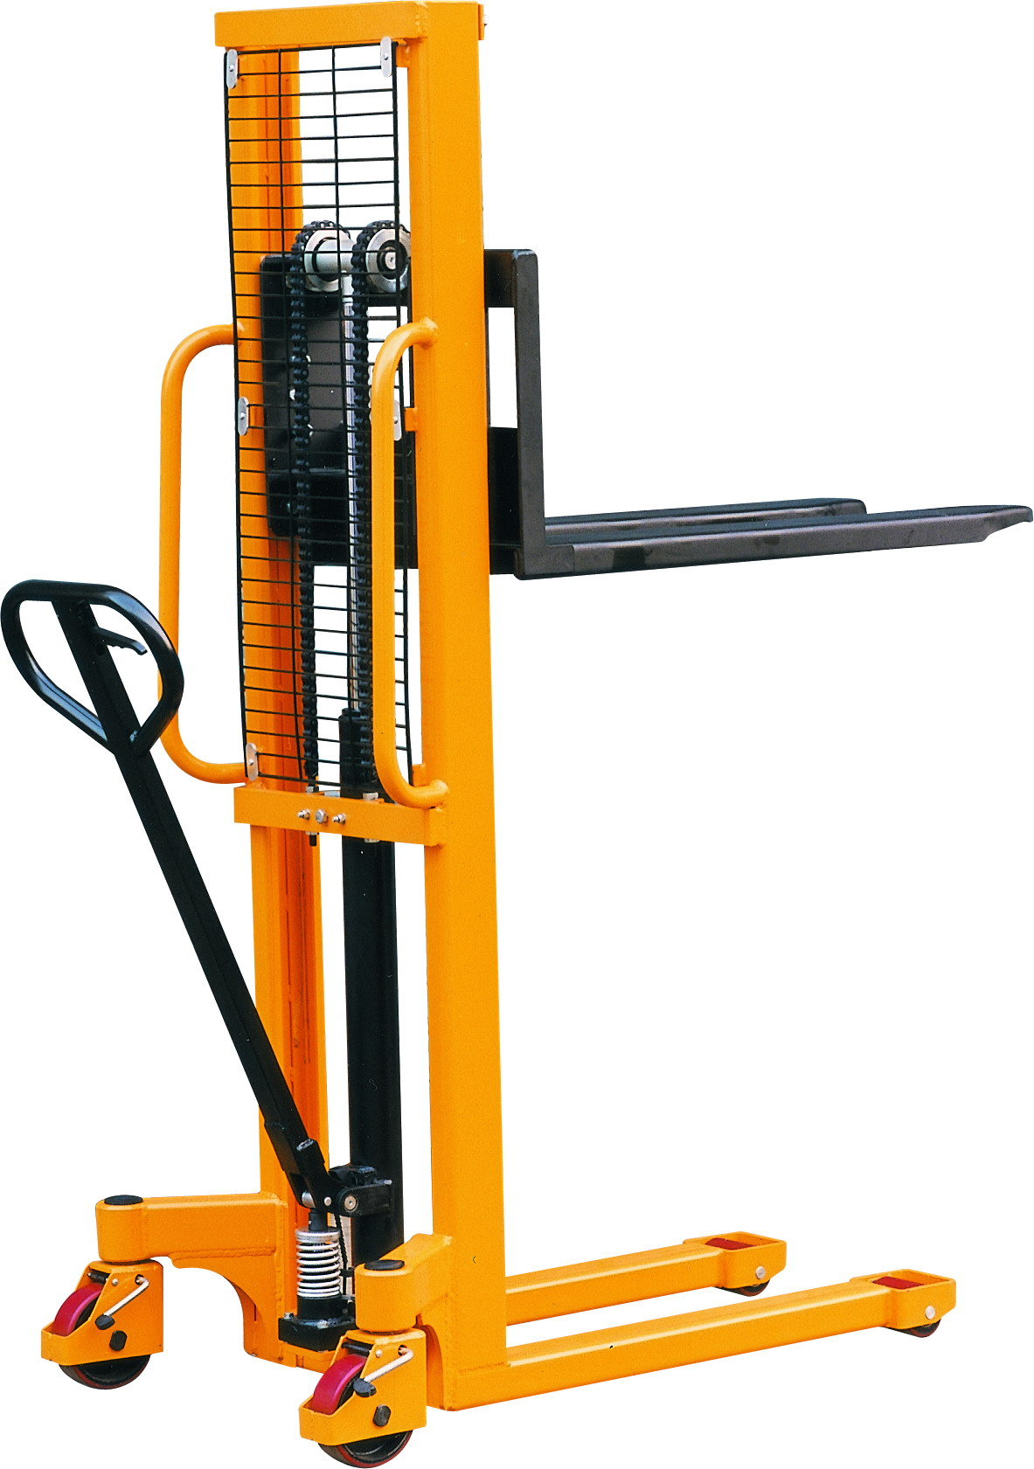

Note: The Owner/Operator must read carefully and understand all the information presented here before operation.

IMPORTANT
Please read, understand and follow these safety rules and operating instructions before operating this machine. Only trained and authorized personnel should be permitted to operate this machine. Please replace Part No. 138 with hole prior to use. (See P9)

l. Safety Rules
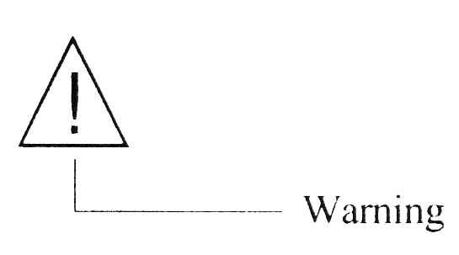
Failure to obey tile instructions and safety rules in this manual may result in death or serious injury.
1.1 Do Not Operate Unless:
1 ) You learn and practice the principles of safe machine operation contained in this operating manual.
――Avoid hazardous situations.
――Always perform a pre-operation inspection.
――Always perform the function tests prior to use.
――Inspect the workplace.
――Only use the machine as a material lift.
2) You read, understand and obey:
――Manufacturer's instructions and safety rules
――Employee's safety rules and worksite regulations
――Applicable governmental regulations
1.2 To Avoid Hazardous Situations:
1) Fall Hazards
Do not use as a personnel lifting platform or step.
Do not load unstable or loosely stacked loads.
2) Tip-over Hazards
Do not overload the machine. Check load diagram on the machine for different centered capacity machine.
Do not raise the load unless the machine is on a firm, level surface.
Do not move the machine with a raised load, except for minor positioning.
Do not operate the machine in strong or gusty winds.
Prior to use, check the work area for drop-offs, holes, bumps, debris, unstable surfaces or other possible hazardous conditions.
Do not subject the machine to horizontal force by raising or lowering a fixed or overhanging load.
3) Collision hazards
Do not lift if the load is not properly centered on the forks. Check load diagram on the machine for correct load center position.
Check the work area for overhead obstruction or other possible hazards.
Do not stand under or allow personnel under the machine when the load is raised.
Do not lower tile load unless the area below is clear of personnel and obstructions.
4) Bodily Injury Hazard
Always keep hands and fingers away from pulleys, the carriage and other potential pinch points.
5) Improper Use Hazard
Never leave a machine unattended with a load. Unauthorized personnel may attempt to operate the machine without proper instruction creating an unsafe situation.
6) Damaged Machine Hazards
Do not use a damaged or malfunctioning machine.
Do not use a machine with a worn, damaged or more than 3% elongation chain.
Be sure that all decals arc in place and legible.
Maintain proper lubrication of chain and other movable parts.
7) Lifting Hazard
Use proper lifting techniques to load the machine.

2. Pre-operation Inspection
The operator should perform a visual inspection prior to each work shift to discover if anything is wrong with a machine.
2.1 Be sure that the instruction manual is complete, legible and available for reference.
2.2 Be sure that all decals are legible and in place.
2.3 Checking the following components or areas for damage and improperly installed, loose or missing parts:
~ Pump Unit and Related Components
~ Base Compo~ loll! S
~ Legs
~ Rollers
~ Frame
~ Chain and Pulleys
~ Casters
~ Forks
~ Brake System
~ Handle
~ Nuts, Bolts and Other Fasteners
2.4 Check entire machine for:
~ Dents or damage
~ Corrosion or oxidation
~ Cracks in welds or structural components

3. Function Tests
The operator must follow the step-by-step instructions to test all machine functions.
3.1 Test the Brake Operation
1) Press down on the foot pedal to lock the brake.
2) Push the machine. The machine should not move.
3) Pull up on the foot pedal to release the brake.
4) Push the machine. It should now move freely.
3.2 Test the Control Lever Functions
1) Set the control lever in the ASCENT position.
The carriage should rise to the top of the mast while pumping the handle.
The carriage should move smoothly, free of hesitation and binding.
2) Set the control lever in the NEUTRAL position.
The carriage should not rise or lower while pumping the handle.
3) Set the control lever in the LOWER position.
The carriage should lower into the mast. The carriage should move smoothly, free of hesitation and binding.

Note: A damaged or malfunctioning machine must never be used. If damage or malfunctions are discovered during pre-operation inspection or function tests, the machine must be tagged and removed from service. Repairs to the machine may only be made by a qualified service technician and according to the manufacturer’s instructions. After repairs are completed, the operator must perform a pre-operation inspection and function test again before putting the machine into service.

4.Workplace inspection
To operate the machine safely, the operator should inspect the workplace prior to moving the machine to the workplace.
Be aware of and avoid the following hazardous situations:
1) Drop-offs or holes
2) Bumps and floor obstructions
3) Debris
4) Overhead obstructions and high voltage conductors
5) Hazardous locations
6) Inadequate surface support to withstand all load forces imposed by the machine
7) Wind and weather conditions
8) All other possible unsafe conditions

5. Operating Instructions
Using the machine for any purpose other than lifting material is unsafe.
5.1 Raising and Lowering Load
1) Please load centrally across the forks. Check the load diagram oil tile machine for correct load center position.
2) Raise the load by pumping the handle ill the ASCENF position.
3) Lower the load by setting the control lever in the LOWER position.
5.2-Moving Machine with a Load
It is best to move the machine without load. Moving a raised load should be restricted to positioning for loading and unloading. If it is necessary to move the machine with a raised load, understand and obey the following safety rules:
1) Area is level and clear of obstructions.
2) Load is correctly centered on the forks.
3) Avoid sudden starts and stops.
4) Travel with load in the lowest possible position.
5) Do not tilt the machine back with a raised load by pulling the C-shape handle on the mast.
6) Keep personnel away from machine and load.
5.3 Moving Machine on Small Slopes
The machine shall not be used on gradients. If it is necessary to negotiate small slopes for the purposes of moving the truck between buildings etc., understand and obey the following safety rules:
1. The gradient shall be no more than 2%.
2. The machine shall be unloaded.
3. The forks shall be facing downgrade.
5.4 Actual Operating Capacity
The actual operating capacity of the machine is the responsibility of the user. It may depend on the operator, floor and machine conditions and frequency of the load handling cycle.
If the load exceeds the actual operating capacity, the operator must be assisted by one or more persons.

6. Maintenance
6.1 Periodic Maintenance
Periodic maintenance will prolong the lifetime of the machine.
See the table below for period of maintenance.

Item | Check | Period
Item | Check | 1 month | 6 months | 12 months
Frame | Check the loading parts |  | ·
Wheels | Check wearing bearing and bearing housing | ·
Turning | Check whether it turns properly | ·
Hydraulic unit | Oil level  Change oil  Check safety |  | · | ·  ·
Lifting chain | Check the extension rate and wear | ·
Brake | Check whether it functions properly | ·
Moveable parts | Check lubrication and tear | ·

6.2 Oil
1) Add oil
If the forks do not lift to maximum height, you should add oil. Restore the fluid level in the reservoir to 2mm below the oiling hole, this must be with the forks in the lowered position.
2) Change oil
Drain the oil in pump unit off. Then add oil as item 1 ).
3) Use the hydraulic type oil according to the temperature scale below.

Temperature | Oil
-20℃－40℃ | L-HM46 Hydraulic oil (equivalent to ISO VG46)

6.3 How To Expel Air Form The Pump Unit
Air may enter the unit when the seals are replaced. Lift the control lever to the LOWER position, and then move the handle up and down for dozens of times.
7. Troubles shooting

No. | Trouble | Cause | Action
1 | The forks do not lift to maximum height. | Not enough hydraulic oil. | Add more oil.
2 | The forks do not lift up. | Not enough hydraulic oil.  The oil has impurities.  Discharge valve is out of adjustment.  Air in the hydraulic oil. | Add more oil.  Change the oil.  Adjust the setting screw(140M).  Expel the air(see item 6.3).
3 | The forks do not descend. | The rod(1301) is deformed resulting from seriously unbalanced load.  A part has been broken or been deformed resulting from unbalanced load.  The setting screw(140M) is not in the correct position. | Replace the rod (1301).  Repair or replace component.  Adjust the setting screw (140M).
4 | Leaks | Seals worn out or damaged.  Some parts may be cracked or worn out. | Replace seals with new ones.  Check and replace with new ones.
5 | The forks descend without being lowered. | Impurities in the oil cause the discharge valve(B) to fail to close.  Air in the oil.  Seals worn or damaged.  Discharge valve(B) is out of adjustment. | Replace with filtered oil.  Expel the air(see item 6.3).  Replace with new ones.  Adjust the setting screw(140M).

Note: Do not attempt to repair the hand hydraulic stacker unless you are trained and authorized to do so.
8.Specifications
Model PA0515
Capacity 500kg
Maximum fork height 1500mm
Minimum fork height 88mm
Fork width 160mm
Fork length 1150mm
Overall fork width fixed: 540mm
adjustable: 346~710mm
Load roller φ80 x 70mm
Steering wheel φ150 x 50mm
Overall length 1604mm
Overall width 794mm
Overall height 1974mm
Net weight 210kg

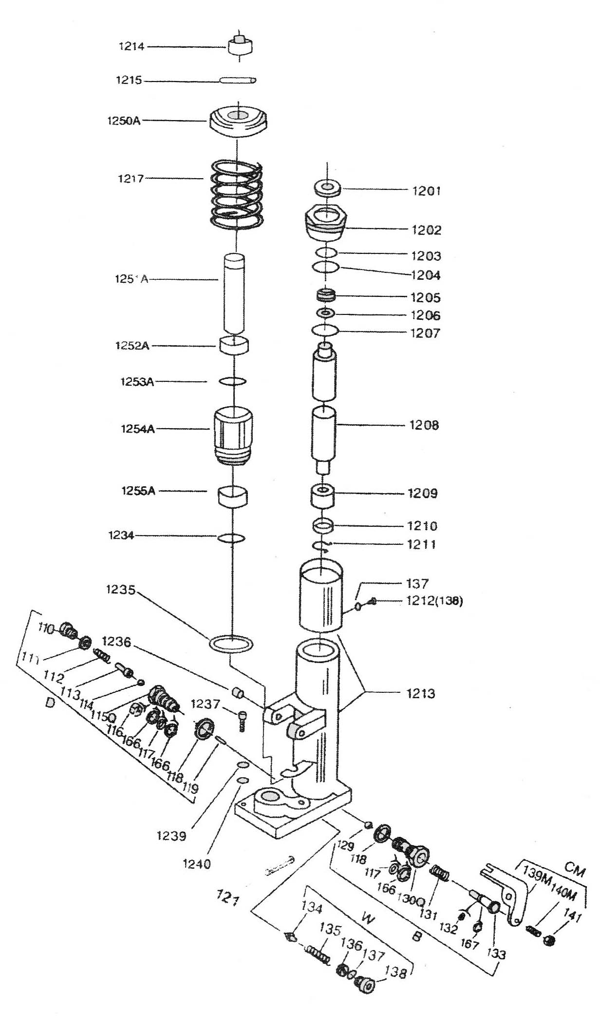
Parts List of Pump Unit (Standard)

Parts No. | Description | Q’ty | Parts No. | Description | Q’ty
1201 | Dust proof ring | 1 | 1255A | Seal ring | 1
1202 | Cylinder | 1 | 110 | Screw | 1
1203 | O-ring | 1 | 111 | Red copper washer | 1
1204 | O-ring | 1 | 112 | Spring | 2
1205 | Seal ring | 1 | 113 | Pressure rod | 1
1206 | Spacing washer | 1 | 114 | Steel ball | 1
1207 | O-ring | 1 | 115Q | Pressure valve body | 1
1208 | Rod | 1 | 116 | Split ring | 1
1209 | Guide casing | 1 | 166 | Retainer | 1
1210 | Washer | 1 | 117 | O-ring | 1
1211 | Retaining ring | 1 | 118 | Red copper washer | 2
1212 | Screw | Each 1 | 119 | Steel needle | 1
1213 | Welded bond | 1 | 121 | Spring pin | 1
1214 | Pressure bond | 1 | 129 | Steel ball | 1
1215 | Spring pin | 1 | 130Q | Discharge valve body | 1
1217 | Spring | 1 | 131 | Spring | 1
1234 | O-ring | 1 | 132 | O-ring | 1
1235 | Red copper washer | 1 | 167 | Retainer | 1
1236 | Bushing | 2 | 133 | Discharge valve shaft | 1
1237 | Bolt | 4 | 134 | Valve taper core | 1
1239 | Spring washer | 4 | 135 | Spring | 1
1240 | Plain washer | 4 | 136 | Pressure regulating screw | 1
1250A | Spring cover | 1 | 137 | O-ring | 1
1251A | Pump plug | 1 | 138 | Screw | 1
1252A | Dust proof ring | 1 | 139M | Crank link | 1
1253A | O-ring | 1 | 140M | Setting screw | 1
1254A | Pump body | 1 | 141 | Nut | 1
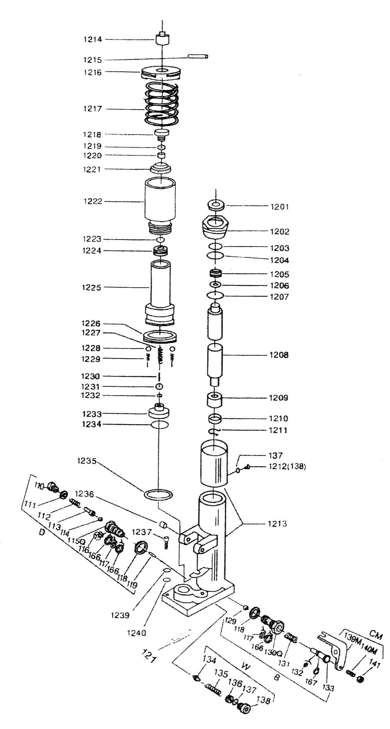

Parts List of Pump Unit (Quick Lift)

Parts No. | Description | Q’ty | Parts No. | Description | Q’ty
1201 | Dust proof ring | 1 | 1234 | O-ring | 1
1202 | Cylinder | 1 | 1235 | Red copper washer | 1
1203 | O-ring | 1 | 1236 | Bushing | 2
1204 | O-ring | 1 | 1237 | Bolt | 4
1205 | Seal ring | 1 | 1239 | Plain washer | 4
1206 | Spacing washer | 1 | 1240 | Steel ball | 4
1207 | O-ring | 1 | 110 | Screw | 1
1208 | Rod | 1 | 111 | Red copper washer | 1
1209 | Guide casing | 1 | 112 | Spring | 1
1210 | Washer | 1 | 113 | Pressure rod | 1
1211 | Retaining ring | 1 | 114 | Steel ball | 1
1212 | Screw | Each 1 | 115Q | Pressure valve body | 1
1213 | Welded bond | 1 | 116 | Split ring | 1
1214 | Pressure bond | 1 | 166 | retainer | 3
1215 | Spring pin | 1 | 117 | O-ring | 2
1216 | Spring cover | 1 | 118 | Red copper washer | 2
1217 | Spring | 1 | 119 | Steel needle | 1
1218 | Screw | 1 | 121 | Spring pin | 1
1219 | O-ring | 1 | 129 | Steel ball | 1
1220 | Pressure regulating screw | 1 | 130Q | Discharge valve body | 1
1221 | Dust proof ring | 1 | 131 | Spring | 1
1222 | Pump body | 1 | 132 | O-ring | 1
1223 | O-ring | 1 | 167 | Retainer | 1
1224 | Seal ring | 1 | 133 | Discharge valve shaft | 1
1225 | Pump plug | 1 | 134 | Valve taper core | 1
1226 | Seal ring | 1 | 135 | Spring | 1
1227 | Spring | 1 | 136 | Pressure regulating screw | 1
1228 | Steel ball | 2 | 137 | O-ring | 2
1229 | Spring | 2 | 138 | screw | 1
1230 | Pressure rod | 1 | 139M | Crank link | 1
1231 | Steel ball | 1 | 140M | Setting screw | 1
1232 | O-ring | 1 | 141 | Nut | 1
1233 | Valve reseater | 1

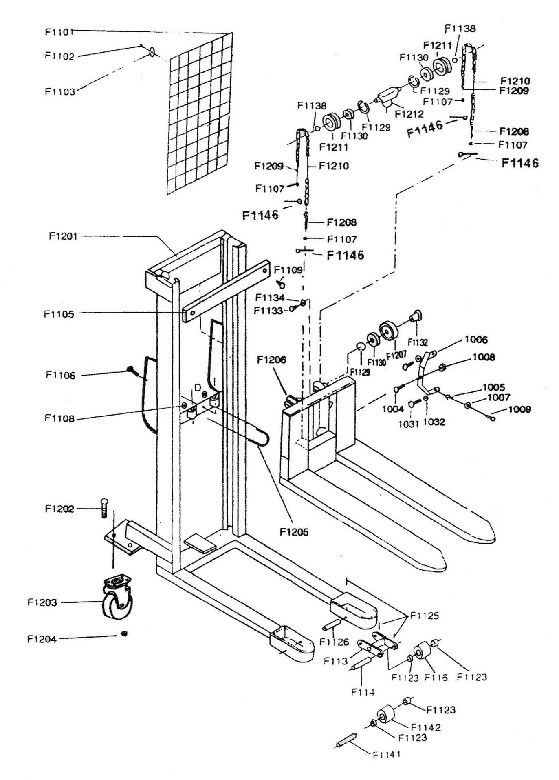
Parts List of Frame (Fixed)

Parts No. | Description | Q’ty | Parts No. | Description | Q’ty
F1201 | Frame | 1 | F1126 | Pivoted axle | 2
F1202 | Bolt | 8 | F1129 | Retaining ring | 6
F1203 | Brake roller | 2 | F1130 | Bearing | 6
F1204 | Self-locking nut | 8 | F1132 | Axle | 4
F1205 | Type U bolt | 1 | F1133 | Bolt | 4
F1206 | Carriage | 1 | F1134 | Washer | 2
F1207 | Roller | 4 | F1138 | Retaining ring | 2
F1208 | Bolt | 2 | F1141 | Pivoted axle(single type) | 2
F1209 | Bolt | 2 | F1142 | Load roller(single type) | 2
F1210 | Chain | 2 | F1146 | Split pin | 4
F1211 | Chain pulley | 2 | F113 | Adjustable bracket | 2
F1212 | Chain pulley bracket | 1 | F114 | Load roller axle(tandem type) | 4
F1101 | Safety net | 1 | F116 | Load roller(tandem type) | 4
F1102 | Screw | 6 | 1004 | Bolt | 2
F1103 | Washer | 6 | 1005 | Retaining ring | 4
F1105 | Spacing plate | 1 | 1006 | Roller bracket | 2
F1106 | Rubber cushion | 1 | 1007 | Roller | 4
F1107 | Hexagon nut | 4 | 1008 | Nut | 2
F1108 | Self-locking nut | 2 | 1009 | Roller axle | 4
F1109 | Bolt | 2 | 1031 | Bolt | 4
F1125 | Spring pin | 6 | 1032 | Nut | 4

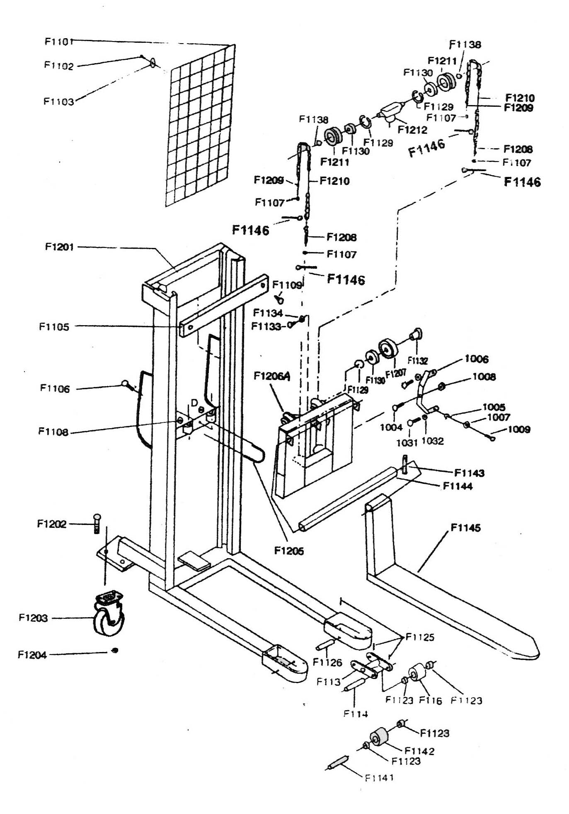

Parts List of Frame (Adjustable)

Parts No. | Description | Q’ty | Parts No. | Description | Q’ty
F1201 | Frame | 1 | F1130 | Bearing | 6
F1202 | Bolt | 8 | F1132 | Axle | 4
F1203 | Brake roller | 2 | F1133 | Bolt | 4
F1204 | Self-locking nut | 8 | F1134 | Washer | 2
F1205 | Type U bolt | 1 | F1138 | Retaining ring | 2
F1206A | Welding bond | 1 | F1141 | Pivoted axle(single type) | 2
F1207 | Roller | 4 | F1142 | Load roller(single type) | 2
F1208 | Bolt | 2 | F1143 | Retaining ring | 2
F1209 | Bolt | 2 | F1144 | Shaft | 1
F1210 | Chain | 2 | F1145 | Adjustable fork | 2
F1211 | Chain pulley | 2 | F1146 | Split pin | 4
F1212 | Chain pulley bracket | 1 | F113 | Adjustable bracket | 2
F1101 | Safety net | 1 | F114 | Load roller axle(tandem type) | 4
F1102 | Screw | 6 | F116 | Load roller(tandem type) | 4
F1103 | Washer | 6 | 1004 | Bolt | 2
F1105 | Spacing plate | 1 | 1005 | Retaining ring | 4
F1106 | Rubber cushion | 1 | 1006 | Roller bracket | 2
F1107 | Hexagon nut | 4 | 1007 | Roller | 4
F1108 | Self-locking nut | 2 | 1008 | Nut | 2
F1109 | Bolt | 2 | 1009 | Roller axle | 4
F1125 | Spring pin | 6 | 1031 | Bolt | 4
F1126 | Pivoted axle | 2 | 1032 | Nut | 4
F1129 | Retaining ring | 6

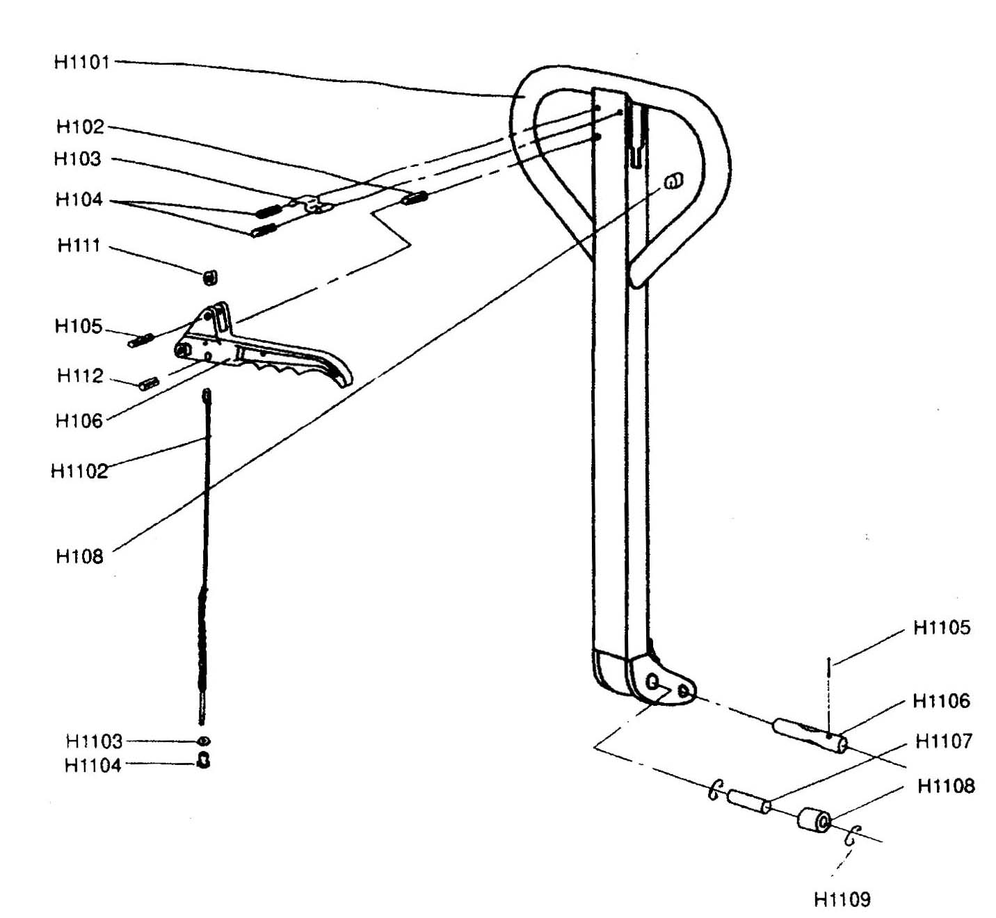

Parts List of Handle

Parts No. | Description | Q’ty | Parts No. | Description | Q’ty
H1101 | Handle | 1 | H102 | Spring pin | 1
H1102 | Rod and chain | 1 | H103 | Spring leaf | 1
H1103 | Nut | 1 | H104 | Spring pin | 2
H1104 | Nut | 1 | H105 | Spring pin | 1
H1105 | Spring ring | 1 | H106 | Control level | 1
H1106 | Pin | 1 | H108 | Rubber cushion | 1
H1107 | Axle | 1 | H111 | Nylon roller | 1
H1108 | Steel roller | 1 | H112 | Spring pin | 1
H1109 | Retaining ring | 2

