Instruction Manual

Vertical Drum Lifters/Dispensers

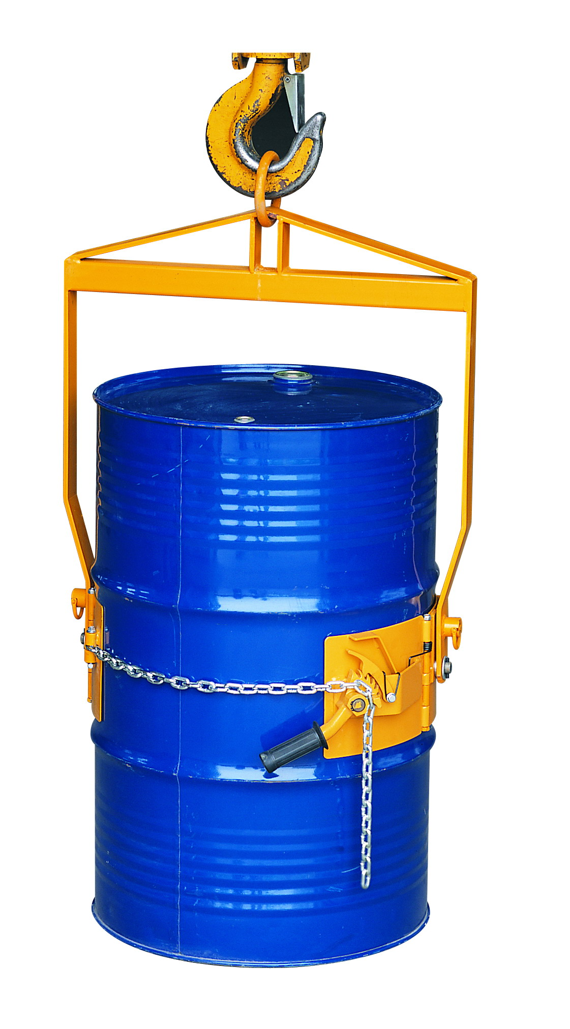
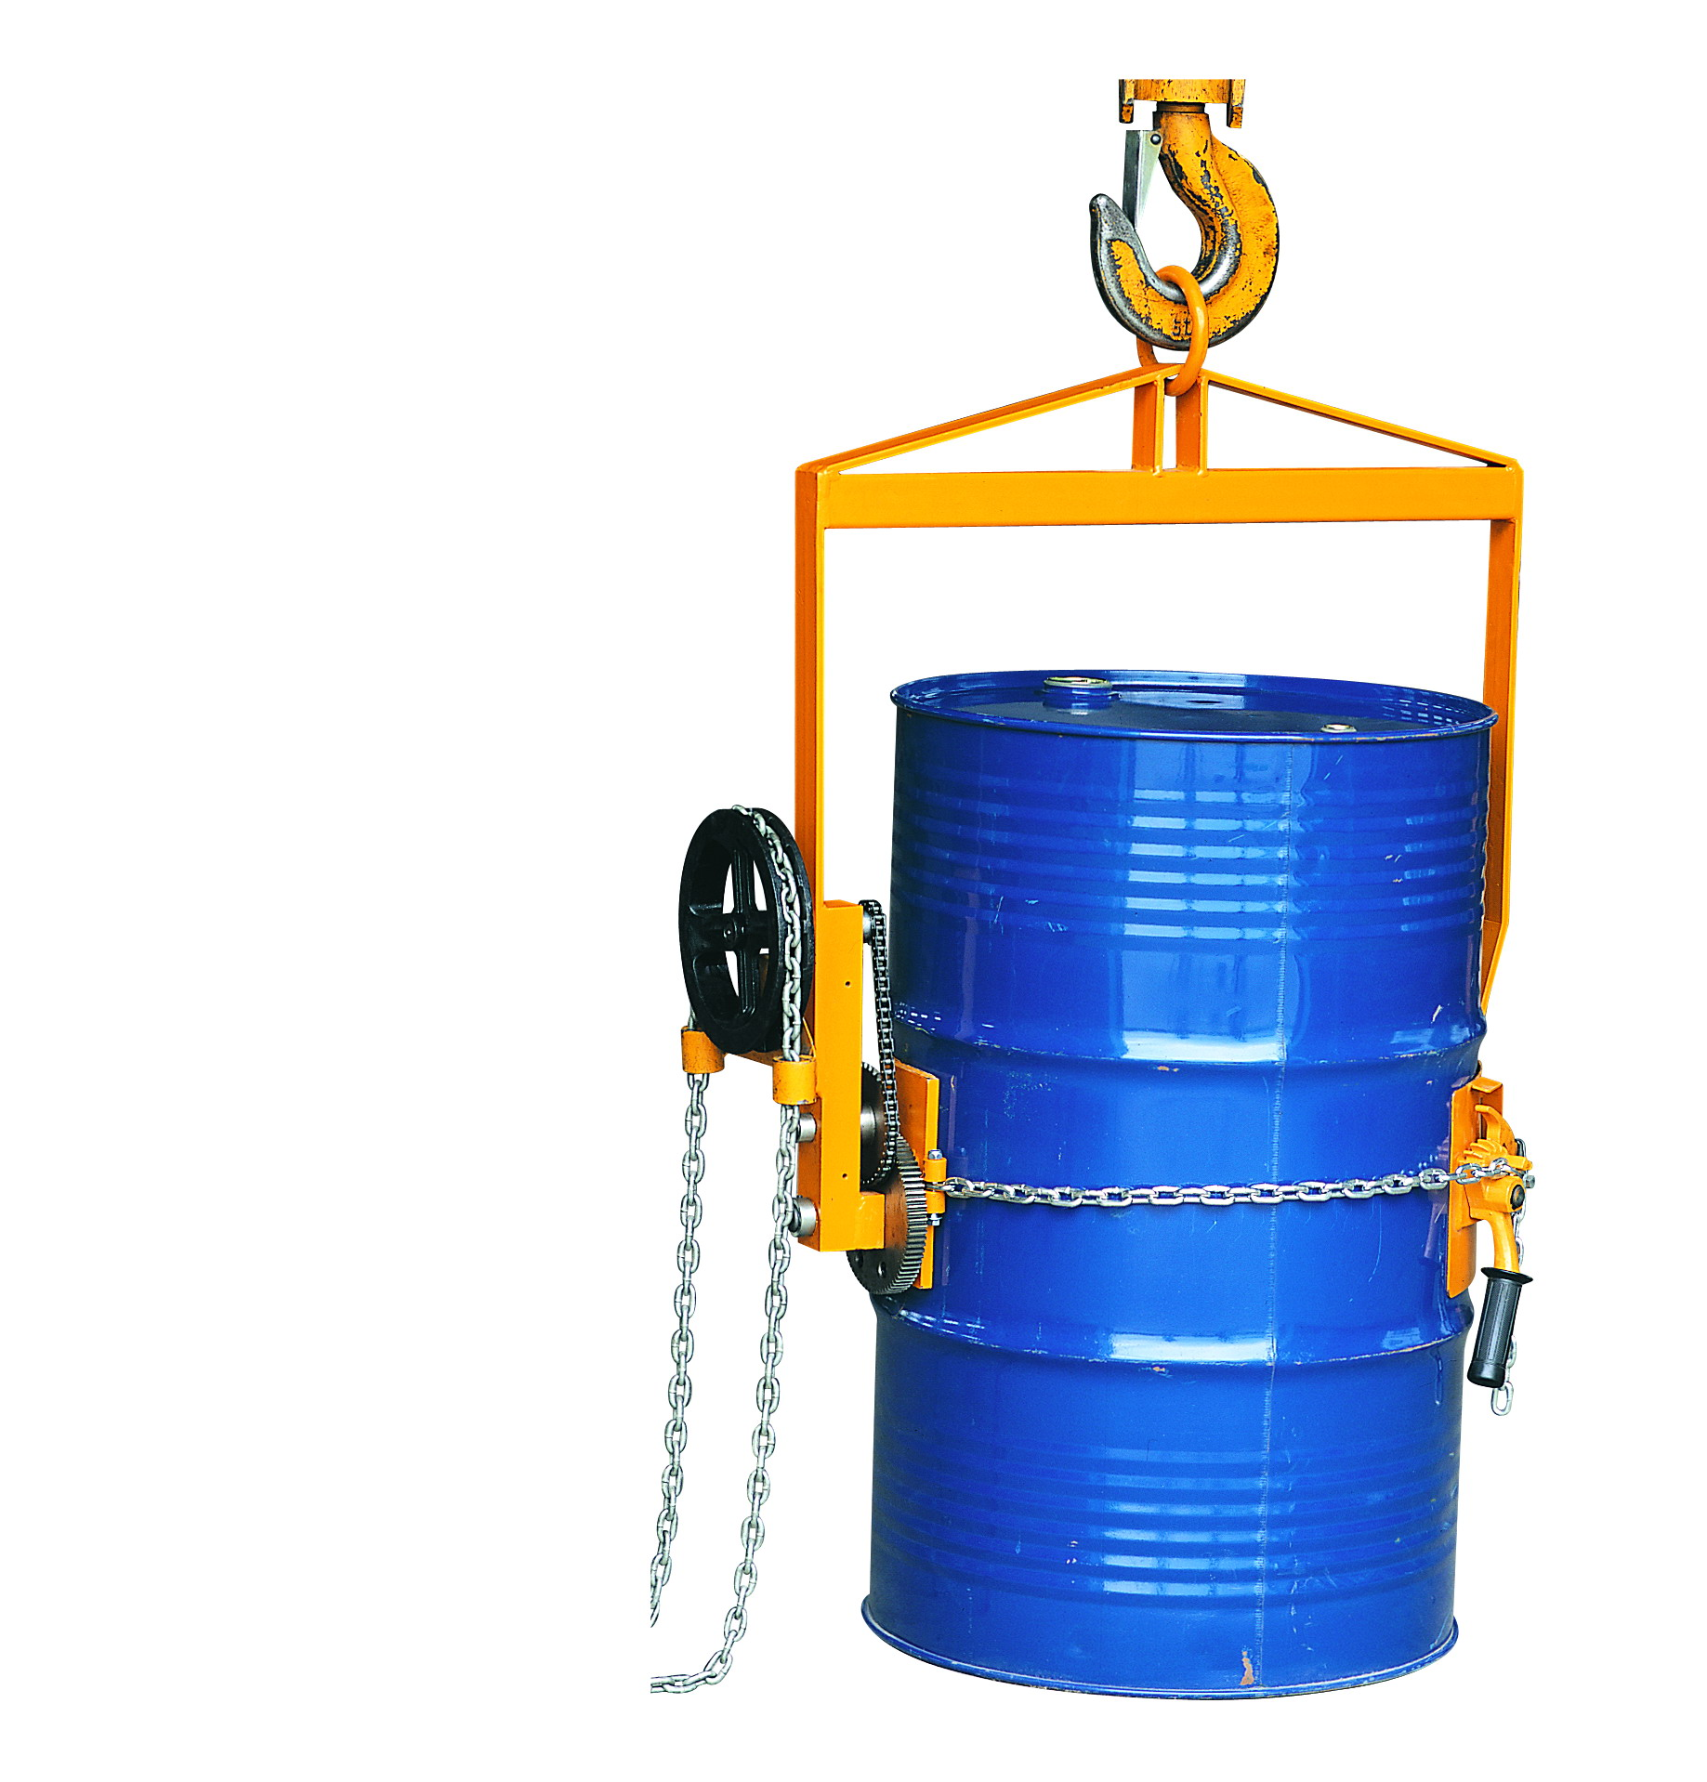

LM800

LG800

Note: The Owner/Operator must read carefully and understand
all the information presented here before operation.

Content

1. | Figure and Specification…………………………….. |  |  | 2
 | 1.1 | Figure…………………………………………. |  | 2
 |  | 1.1.1 | Manual Type LM800………………. | 2
 |  | 1.1.2 | Geared Type LG800….…………… | 3
 | 1.2 | Specification…………………………………. |  | 3
2. | Part Name……………………………………………. |  |  | 4
3. | Warning………………………………………………. |  |  | 4
4. | Operation Instructions………………………………. |  |  | 4
5. | Exploded View & Part List………………………….. |  |  | 5
 | 5.1 | LM800………………………………………… |  | 5
 | 5.2 | LG800………………………………………… |  | 7

THANK YOU FOR USING THIS DRUM LIFTERS. FOR YOUR SAFETY AND CORRECT OPERATION, PLEASE CAREFULLY READ THIS INSTRUCTION BEFORE USING IT.

NOTE: All of the information reported herein is based on data available at the moment of printing. The factory reserves the right to modify its own products at any moment without notice and incurring in any sanction. So it is suggested to always verify possible updates.

- FIGURE AND SPECIFICATION
  - Figure
1.1.1 Manual Type LM800
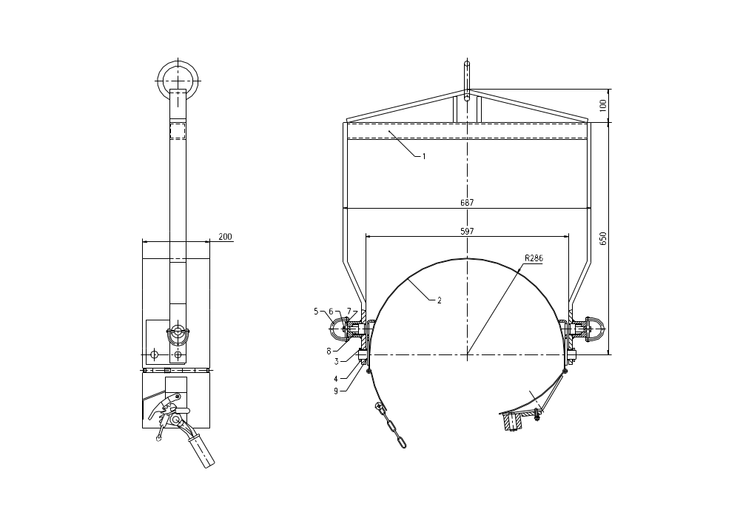
1.1.2 Geared Type LG800
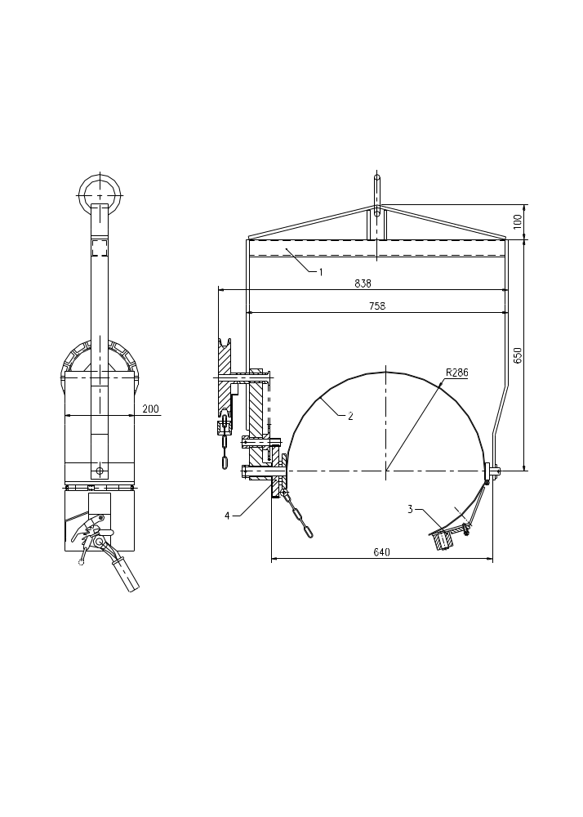

1.2 Specification
Model |  | Length  (mm) |  | Width  (mm) |  | High  (mm) | Diameter  (mm) | Net Weight  (kg) | Capacity  (lbs)
LM800 |  | 890 |  | 687 |  | 200 | φ572 | 20 | 800
LG800 | 940 |  | 838 |  | 225 |  | φ572 | 45 | 800

- PART NAME
- Lifter frame
- Hoop
- Clamp
- Rotator assembly
- Geared driver assembly
- Chain wheel

- WARNING
- Do not overload this drum lifter beyond its rated capacity, drum must be clamped at the center position to avoid causing damage.
- Do not stand under the drum lifter or when it is moving.
- Do not operate when drum lifter go wrong.

4. OPERATING INSTRUCTIONS
4.1 Enclose lifter to hook, and ensure it is installed accurately, hard and safety.
4.2 Hoop cling the drum closely at the horizontal position, buckle the chain on the geared spanner groove and turn spanner, the drum will be clamped and inspect it clamping hard.
4.3 Loosen the LM800 hook when the drum is hanged up, the drum can be turn in 90º.The drum will be clamped when loosen the replacement hook.
4.4 Loosen the spanner freewill when the drum is hanged in the air, the drum can be turn in 360º, if stop , it will be clamped in the freewill angle.
4.5 Turn spanner with appropriate force at the clamped direction, while loosen the connecting of geared hook and geared spanner, if chain is unstuck, the drum can be taken out.
  - EXPLODED VIEW & PART LIST
5.1 LM800

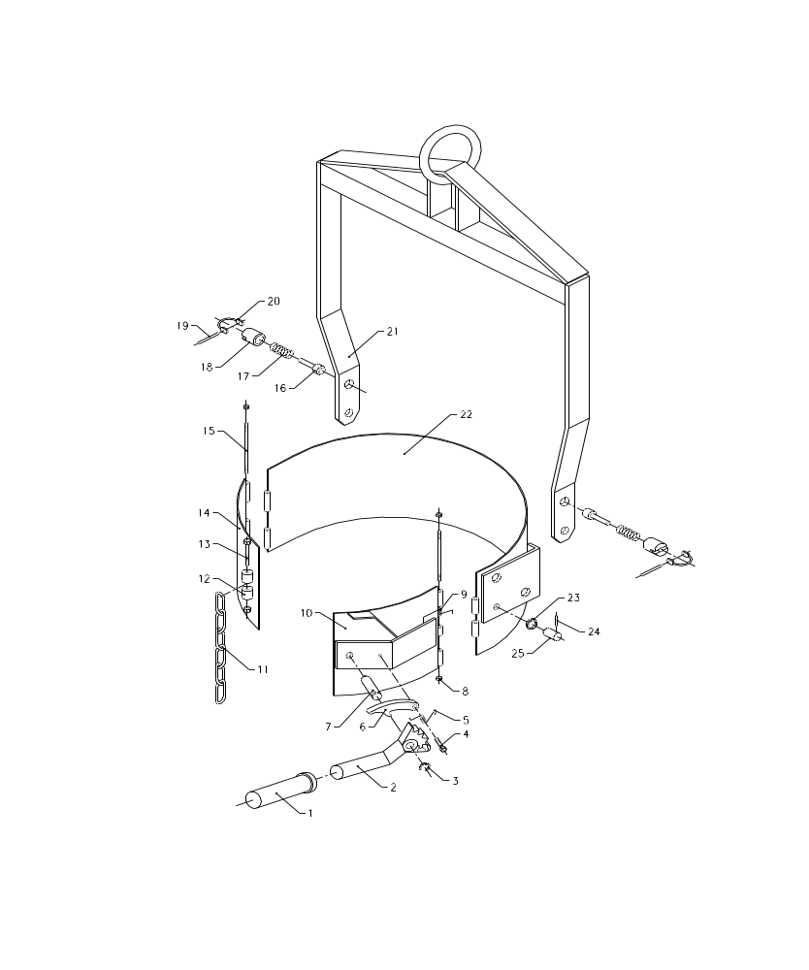
No. | Description | Qty | Remark
1 | Rubber Bushing | 1
2 | Geared Spanner | 1
3 | Retaining Ring | 1
4 | Hexagon Bolt | 1
5 | Spring | 1
6 | Geared Hook | 1
7 | Pin | 1
8 | Nut | 2
9 | Spring | 1
10 | Clamped Board | 1
11 | Chain | 1
12 | Connected Ring | 2
13 | Bolt | 1
14 | Connected Board | 1
15 | Pin | 2
16 | Located Pin | 2
17 | Spring | 2
18 | Welded Seat | 2
19 | Pin | 2
20 | Hook | 2
21 | Hoist Unit | 1
22 | Hoop Unit | 1
23 | Clamped Ring | 2
24 | Pin Axles | 2
25 | Pin | 2

5.2 LG800

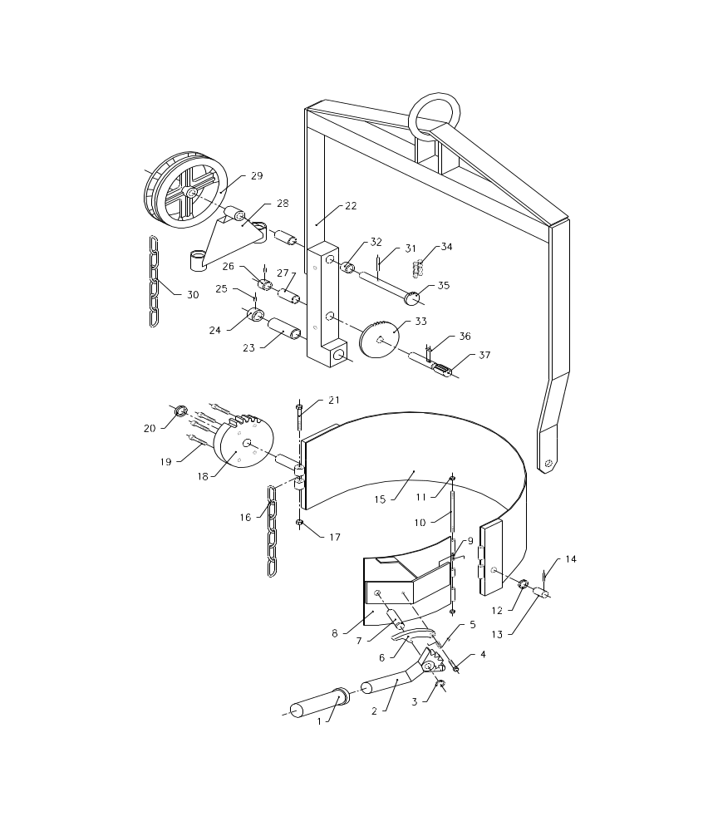
No. | Description | Qty | No. | Description | Qty
1 | Rubber Bushing | 1 | 21 | Bolt | 2
2 | Geared Spanner | 1 | 22 | Lift | 1
3 | Retaining Ring | 1 | 23 | Bush | 1
4 | Hexagonal Bolt | 1 | 24 | Aligning Ring | 1
5 | Spring | 1 | 25 | Aligning Bolt | 2
6 | Geared Hook | 1 | 26 | Aligning Ring | 1
7 | Pin | 1 | 27 | Bush | 1
8 | Clamped Board | 1 | 28 | Chain Board | 1
9 | Spring | 1 | 29 | Chain Wheel | 1
10 | Pin | 1 | 30 | Chain | 1
11 | Nut | 2 | 31 | Aligning Pin | 1
12 | Clamped Ring | 1 | 32 | Clamped Ring | 1
13 | Pin | 1 | 33 | Chain Wheel | 1
14 | Spring | 1 | 34 | Chain | 1
15 | Hoop | 1 | 35 | Chain Wheel Axis | 1
16 | Chain | 1 | 36 | Plane Key | 1
17 | Nut | 1 | 37 | Geared Axis | 1
18 | Gear | 1
19 | Bolt | 4
20 | Clamped Ring | 1

